***FEBRUARY***

**Birthdays**

*James Canterbury 02/01*

*Chelsey Ooten 02/02*

*Israel Canterbury 02/04*

*Richard Ooten 02/05*

*Jessica Mounts 02/06*

*Trinity & Noah Ball 02/15*

*Anna Canterbury 02/15*

*Gary Canterbury 02/16*

*Daniel Mounts 02/17*

*Ricky Hundley 02/25*

*Sadie Damron 02/26*

**Spiritual Birthdays**

*Brionna Shrum 02/15*

**Anniversary**







***Church Announcements***



**02/20 – Dennis & Julie Heber Speaking**

**02/15 – Hey Ladies! Meeting**

**SERVICE TIMES**

Sunday Teen Group Meeting

9:30 AM

Sunday Morning Service & POWER KIDS

11:00 AM

Wednesday Prayer Service

7:00 PM

***Hey Ladies!***

**6PM – Every 3rd Tuesday**

[***https://www.khchurch.com***](https://www.khchurch.com)

***Growing Families.***

***Harvesting the Kingdom.***

How to give at Kingdom Harvest…

1. <https://www.khchurch.com>; click on the “Giving” tab
2. Text **kingdomharvestwv** to77977 & follow instructions
3. Black basket at the front door

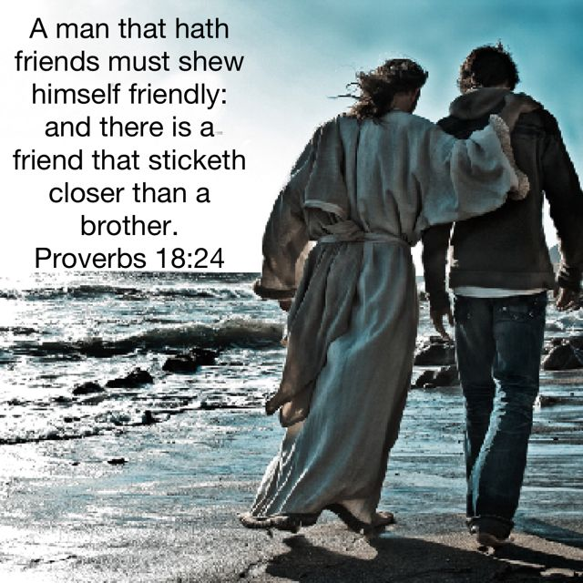

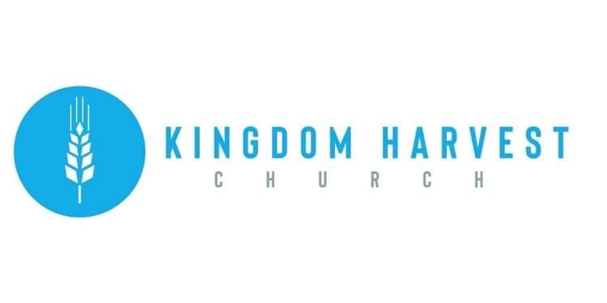

**Pastors Tom & Cristy Canterbury**

***PO Box 545***

***Lenore, WV 25676***

***304-475-3805***

***February 20, 2022***



**KHC Valentine’s Married Couple**

**Date Night 2022**

**Delicious food!**

**Wonderful friends!**

**Memorable Times!**

**Marriage Celebrated – KHC Style. Marriage is perfect when God is in the midst…it takes 3 to have a marriage the way God intended.**

***“Wherefore they are no more twain, but one flesh. What therefore God hath joined together, let no man put asunder. Matthew 19:6”***

***Pay off the Building Challenge!!***

The mortgage on the church building is close to “paid off” status.

Pray, Seek God’s voice, and Make your contributions to the **Mortgage Principal Drive** by Palm Sunday.







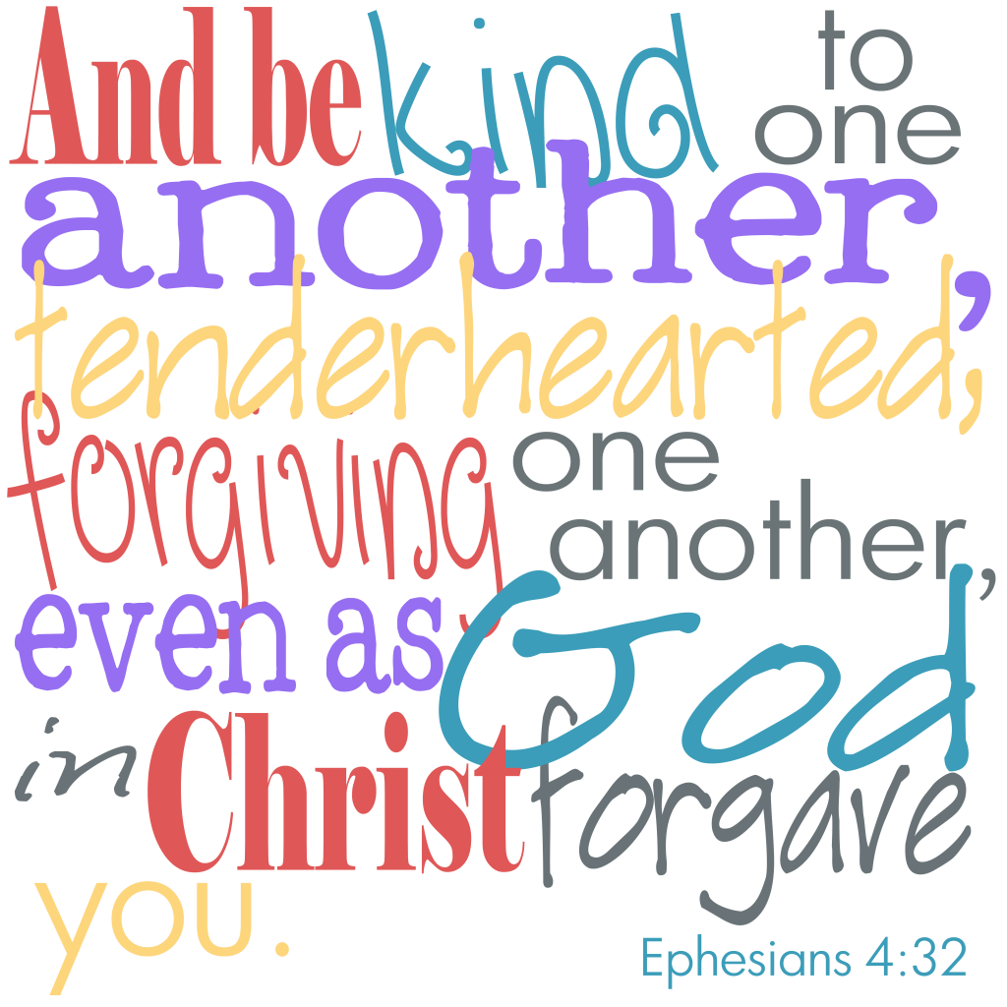





***Hey Ladies!***

**March 15th**