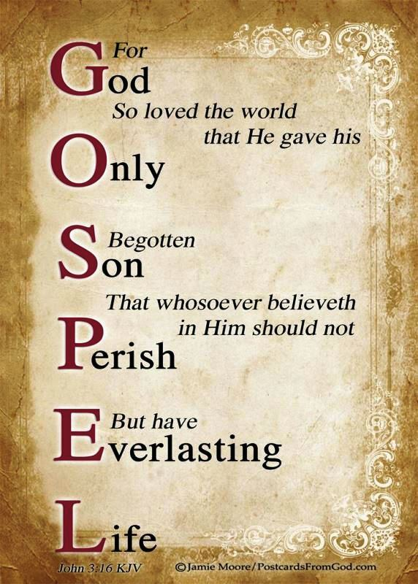

***FEBRUARY***

**Birthdays**

*Chelsey Ooten 02/02*

*Israel Canterbury 02/04*

*Richard Ooten 02/05*

*Jessica Mounts 02/06*

*Trinity & Noah Ball 02/15*

*Anna Canterbury 02/15*

*Ricky Hundley 02/25*

*Sadie Damron 02/26*

**Spiritual Birthdays**

*Brionna Shrum 02/15*

**Anniversary**







***Church Announcements***



**02/15 – Hey Ladies! Meeting**

**02/19 – Valentine’s Dinner**

[***https://www.khchurch.com***](https://www.khchurch.com)

***Growing Families.***

***Harvesting the Kingdom.***

**SERVICE TIMES**

Sunday Teen Group Meeting

9:30 AM

Sunday Morning Service & POWER KIDS

11:00 AM

Wednesday Prayer Service

7:00 PM

***Hey Ladies!***

**6PM – Every 3rd Tuesday**

How to give at Kingdom Harvest…

1. <https://www.khchurch.com>; click on the “Giving” tab
2. Text **kingdomharvestwv** to77977 & follow instructions
3. Black basket at the front door





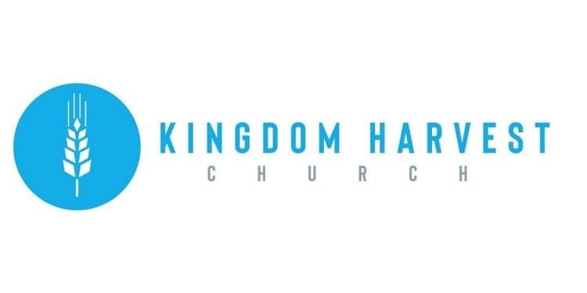

**Pastors Tom & Cristy Canterbury**

***PO Box 545***

***Lenore, WV 25676***

***304-475-3805***

***February 13, 2022***



***Love (Charity)***

***1 Corinthians 13: 4-8***

Love suffereth long

Love is kind

Love envieth not

Love vaunteth not itself

Love is not puffed up

Love doth not behave itself unseemly

Love seeketh not her own

Love is not easily provoked

Love thinketh no evil

Love rejoiceth not in iniquity

Love rejoiceth in the truth

Love beareth all things

Love believeth all things

Love hopeth all things

Love endureth all things

Love never faileth…

*1 Corinthians 13:13*

*And now abideth faith, hope, charity, these three: but the greatest of these is charity.*

***Pay off the Building Challenge!!***

The mortgage on the church building is close to “paid off” status.

Pray, Seek God’s voice, and Make your contributions to the **Mortgage Principal Drive** by Palm Sunday.











*Don’t forget…February 19th*

*KHC’s Valentine’s Dinner*

*For Married Couples*

*See the menu at the front of the church or contact Sister Angie.*

*Be sure to tell Sister Paige or Sister Kyla*

*if you will be there*

*Looking forward to “Date Night” with y’all!!*

*Dennis & Julie Heber will also be there!!*







***Hey Ladies!***

**February 15th**

**Jessica Mounts will be speaking**