***FEBRUARY***

**Birthdays**

*Chelsey Ooten 02/02*

*Israel Canterbury 02/04*

*Richard Ooten 02/05*

*Trinity & Noah Ball 02/15*

*Anna Canterbury 02/15*

*Ricky Hundley 02/25*

*Sadie Damron 02/26*

**Spiritual Birthdays**

*Brionna Shrum 02/15*

**Anniversary**







***Church Announcements***



**02/15 – Hey Ladies! Meeting**

**02/19 – Valentine’s Dinner**

**SERVICE TIMES**

Sunday Teen Group Meeting

9:30 AM

Sunday Morning Service & POWER KIDS

11:00 AM

Wednesday Prayer Service

7:00 PM

***Hey Ladies!***

**6PM – Every 3rd Tuesday**

How to give at Kingdom Harvest…

1. <https://www.khchurch.com>; click on the “Giving” tab
2. Text **kingdomharvestwv** to77977 & follow instructions
3. Black basket at the front door

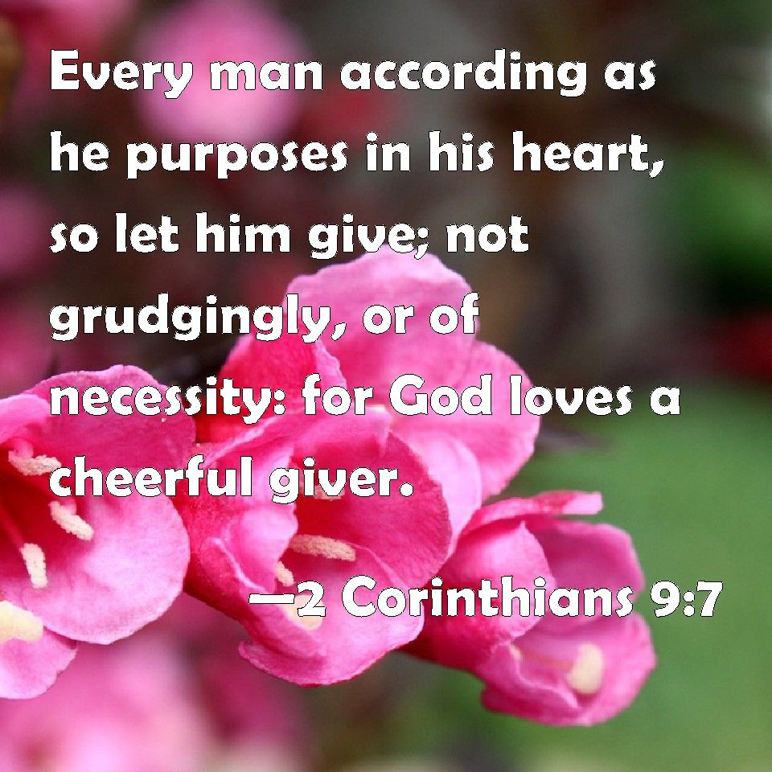

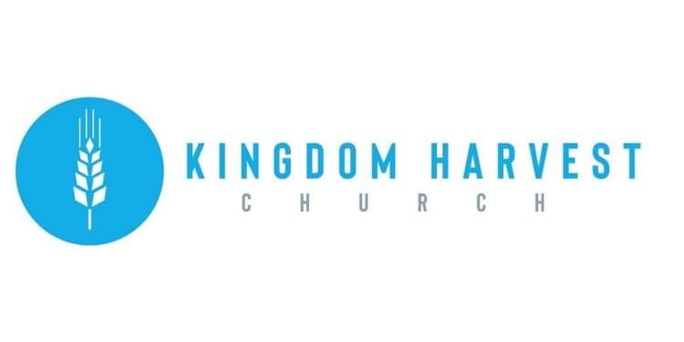

[***https://www.khchurch.com***](https://www.khchurch.com)

***Growing Families.***

***Harvesting the Kingdom.***

**Pastors Tom & Cristy Canterbury**

***PO Box 545***

***Lenore, WV 25676***

***304-475-3805***

***February 06, 2022***

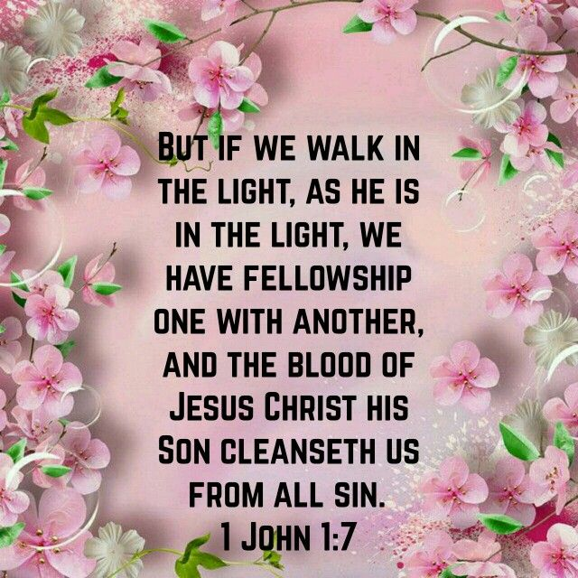****

***Pay off the Building Challenge!!***

This past Sunday, Sr. Pastor Tommy challenged the church members. The mortgage on the church building is close to paid off status.

So, pray, seek God’s voice, and make your contributions (to go towards the principal) by Palm Sunday.





*Don’t forget…February 19th*

*KHC’s Valentine’s Dinner*

*For Married Couples*

*See the menu at the front of the church or contact Sister Angie.*

*Be sure to tell Sister Paige or Sister Kyla*

*if you will be there*

*Looking forward to “Date Night” with y’all!!*

*Dennis & Julie Heber will also be there!!*

***Hey Ladies!***

If you have not been able to attend a “***Hey Ladies!***” meeting,

***YOU***

***HAVE***

***MISSED***

***OUT!!***

**Next meeting is February 15th**

**Jessica Mounts will be speaking**

Fellowship…God’s Word…Bonds Formed… and Birthday Cake!!





[This Photo](https://stewartdollhousecreations.com/cakekit11) by Unknown Author is licensed under [CC BY-SA](https://creativecommons.org/licenses/by-sa/3.0/)