***JANUARY***

**Birthdays**

*Waylon Hundley 01/02*

*Jennifer Horn 01/09*

*Tom Canterbury 01/24*

*Camryn Akers 01/26*

*Abigail Ooten 01/30*

**Spiritual Birthdays**

**Anniversary**







***Church Announcements***



**02/15 – Hey Ladies! Meeting**

**02/19 – Valentine’s Dinner**

**SERVICE TIMES**

Sunday Teen Group Meeting

9:30 AM

Sunday Morning Service & POWER KIDS

11:00 AM

Wednesday Prayer Service

7:00 PM

***Hey Ladies!***

**6PM – Every 3rd Tuesday**

How to give at Kingdom Harvest…

1. <https://www.khchurch.com>; click on the “Giving” tab
2. Text **kingdomharvestwv** to77977 & follow instructions
3. Black basket at the front door

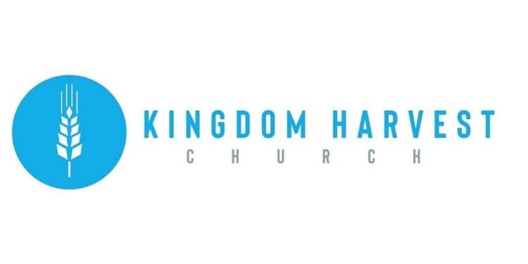

[***https://www.khchurch.com***](https://www.khchurch.com)

***Growing Families.***

***Harvesting the Kingdom.***

**Pastors Tom & Cristy Canterbury**

***PO Box 545***

***Lenore, WV 25676***

***304-475-3805***

**January 30, 2022**

***Hey Ladies!*** Meeting **–** **January**

Read – Pray – Seek wise counsel!!!

Sister Paige Akers ministered on Focused Goal Setting for the January ***Hey Ladies!*** meeting.

Sister Paige

So, plan to join us in February! Sister Jessica Mounts will be ministering. And, as mentioned last month, there will be a “birthday cake” to celebrate the “Ladies” February birthdays!

