***JANUARY***

**Birthdays**

*Jennifer Horn 01/09*

*Tom Canterbury 01/24*

*Camryn Akers 01/26*

*Abigail Ooten 01/30*

**Spiritual Birthdays**

**Anniversary**







***Church Announcements***



**01-02 Jamie Englehart Speaking**

**01-18 Hey Ladies! Meeting**

**SERVICE TIMES**

Sunday Teen Group Meeting

9:30 AM

Sunday Morning Service & POWER KIDS

11:00 AM

Wednesday Prayer Service

7:00 PM

***Hey Ladies!***

**6PM – Every 3rd Tuesday**

How to give at Kingdom Harvest…

1. <https://www.khchurch.com>; click on the “Giving” tab
2. Text **kingdomharvestwv** to77977 & follow instructions
3. Black basket at the front door

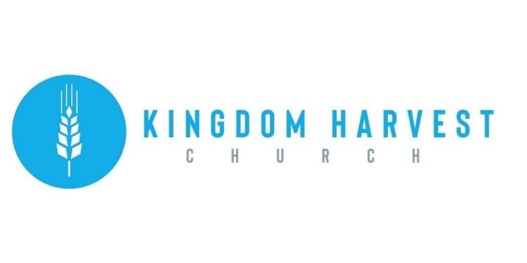

[***https://www.khchurch.com***](https://www.khchurch.com)

***Growing Families.***

***Harvesting the Kingdom.***

**Pastors Tom & Cristy Canterbury**

***PO Box 545***

***Lenore, WV 25676***

***304-475-3805***

**January 2, 2022**

***Hey Ladies!*** Meeting-December:

If you did not get to attend the December ***Hey Ladies!*** meeting, you missed a wonderful time!!!

Sister Joyce Lucas ministered from Genesis 2:18, and asked the question, “Why did God create woman?”

Sister Joyce began by talking about the Creation, and how that after every day of Creation, God said it was good. But, after God created Man, God said it was not good that he should be alone…and the answer to this was Woman. God did not create Woman to be under Man or over Man, but as a “help meet” for Man. God could have made another Man to help, but God made Woman because her talents complemented Man. Men & Women are different and it is these differences that please God.

Sister Joyce also talked about the gifts inside each of us. God placed gifts inside each of us to help each other and show the world God’s love.

After the devotional, there were finger foods, fellowship, and a gift exchange game.

*Beginning in 2022, every* ***Hey Ladies!*** *meeting will have a birthday cake to celebrate birthdays in that month…the cake’s colors will be the birth stone for that month.*

So, plan to join us this month…we would love to fellowship with you!!



KHC welcomes

Jamie Englehart our guest minister today!