

***DECEMBER***

**Birthdays**

*Matthew Reed 12/01*

*Michael Reed 12/01*

*Tyler Lucas 12/10*

*Angie McComis 12/21*

*Chris Akers 12/22*

**Spiritual Birthdays**

**Anniversary**

*Kevin & Tammy Sammons 12/16*







***Church Announcements***



**12-12 Ugly Sweater Sunday**

**12-19 Christmas Cantata (Dennis Heber Speaking)**

**SERVICE TIMES**

Sunday Teen Group Meeting

9:30 AM

Sunday Morning Service & POWER KIDS

11:00 AM

Wednesday Prayer Service

7:00 PM

**Hey Ladies!**

**6PM – Every 3rd Tuesday**

There are many ways to give at Kingdom Harvest…

1. <https://www.khchurch.com>; click on the “Giving” tab
2. Text **kingdomharvestwv** to77977 & follow instructions
3. Black basket at the front door

**UGLY SWEATER SUNDAY!**



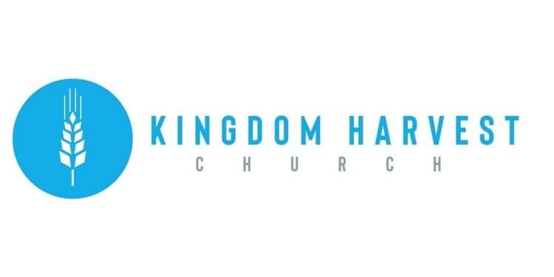

[***https://www.khchurch.com***](https://www.khchurch.com)

***Growing Families.***

***Harvesting the Kingdom.***

**Pastors Tom & Cristy Canterbury**

***PO Box 545***

***Lenore, WV 25676***

***304-475-3805***

**December 12, 2021**



KHC Blessings Box

For most, this time of year brings joy, happiness, peace, and love…and lots of food. Some, however, are not as fortunate. We at KHC are blessed beyond measure.

This Christmas season, remember those less fortunate.

*For ye have the poor with you always, and whensoever ye will ye may do them good… Mark 14:7.*



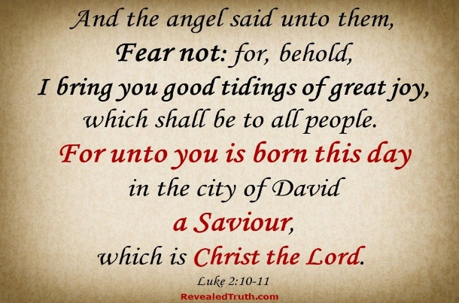

**REMINDER – December 19th**

KHC will present a Christmas Cantata to celebrate the birth of our Savior, Jesus Christ!

And, as a special treat, Dennis Heber will be speaking!

Invite your family & friends to experience Christmas in sound!

Merry Christmas 2021



Color me!! Let’s decorate our bulletin board!! Kids & adults alike can be a part of “coloring” Christmas!!

Bring colored picture next week!!