

***DECEMBER***

**Birthdays**

*Matthew Reed 12/01*

*Michael Reed 12/01*

*Tyler Lucas 12/10*

*Angie McComis 12/21*

*Chris Akers 12/22*

**Spiritual Birthdays**

**Anniversary**

*Kevin & Tammy Sammons 12/16*







***Church Announcements***



**12-12 Ugly Sweater Sunday**

**12-19 Christmas Cantata (Dennis Heber Speaking)**

**SERVICE TIMES**

Sunday Teen Group Meeting

9:30 AM

Sunday Morning Service & POWER KIDS

11:00 AM

Wednesday Prayer Service

7:00 PM

**Hey Ladies!**

**6PM – Every 3rd Tuesday**

There are many ways to give at Kingdom Harvest…

1. <https://www.khchurch.com>; click on the “Giving” tab
2. Text **kingdomharvestwv** to77977 & follow instructions
3. Black basket at the front door



**December is a busy time…celebrating with family and friends…but let’s not forget the most important part…*Jesus* is the reason for the season!!**

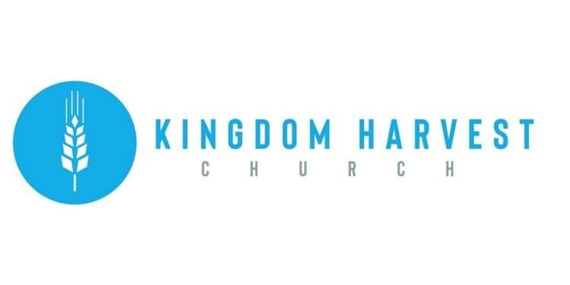

[***https://www.khchurch.com***](https://www.khchurch.com)

***Growing Families.***

***Harvesting the Kingdom.***

**Pastors Tom & Cristy Canterbury**

***PO Box 545***

***Lenore, WV 25676***

***304-475-3805***

**December 5, 2021**



**UGLY SWEATER SUNDAY!**

***Time to ring in the Christmas Season!!***

***Let’s see who has the best/worst one!!***

***Bring it on!!***

**DECEMBER 12TH**







**December 19th**

KHC will present a Christmas Cantata to celebrate the birth of our Savior, Jesus Christ!

And, as a special treat, Dennis Heber will be speaking!

Invite your family & friends to experience Christmas in sound!

