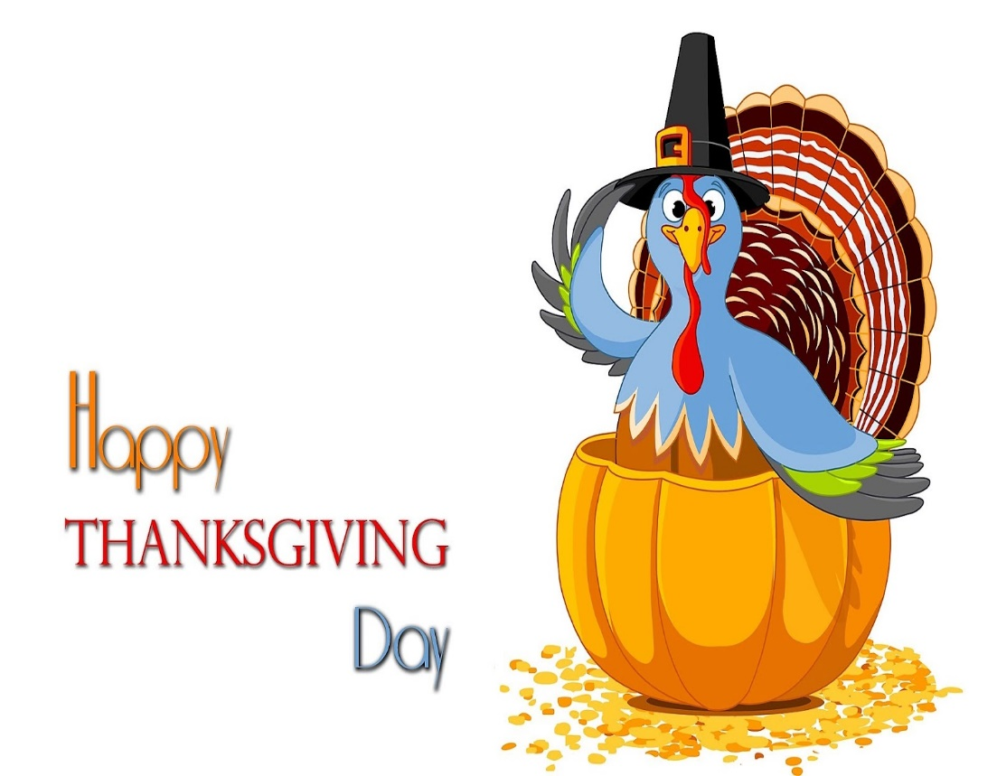

***NOVEMBER***

**Birthdays**

*Lynn Preece 11/03 Lakyn Horn 11/05*

*Caspian Damron 11/08 Gary McComis 11/08*

*Emberly Damron 11/10 Garfield Horn 11/11*

*Cristy Canterbury 11/14 Ezra Smith 11/15*

*Hannah Lucas 11/16 Corbin Damron 11/21*

*Joyce Lucas 11/25*

**Spiritual Birthdays**

*Harold Preece Nov 2004*

**Anniversary**

*Chris & Paige Akers 11/17*

*Garfield & Jennifer Horn 11/23*

*Tommy & Cristy Canterbury 11/24*







***Church Announcements***



**Upcoming events to be announced**

**SERVICE TIMES**

Sunday Teen Group Meeting

9:30 AM

Sunday Morning Service & POWER KIDS

11:00 AM

Wednesday Prayer Service

7:00 PM

**Hey Ladies!**

**6PM – Every 3rd Tuesday**

There are many ways to give at Kingdom Harvest…

1. <https://www.khchurch.com>; click on the “Giving” tab
2. Text **kingdomharvestwv** to77977 & follow instructions
3. Black basket at the front door

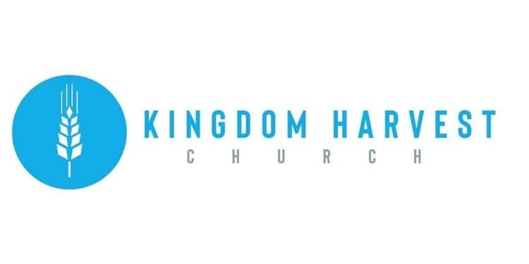

[***https://www.khchurch.com***](https://www.khchurch.com)

***Growing Families.***

***Harvesting the Kingdom.***

**Pastors Tom & Cristy Canterbury**

***PO Box 545***

***Lenore, WV 25676***

***304-475-3805***

**November 21, 2021**



**HEY LADIES!**

***Hey Ladies!*** met this past Tuesday evening. Kyla Smith gave a devotional on Prayer and Fasting…she gave 13 benefits of prayer & fasting, explained the differences in Christian fasting and other religions, and encouraged all ladies to “truly seek God and listen to the Spirit”. After the devotional, personal experiences were shared with all, and a sweet “Spirit” of fellowship & love was felt. The food afterwards fed the body just as God’s Word fed our Soul.

Our next meeting is December 21st. We hope to see you there!! The Ladies will be exchanging small gifts & Joyce Lucas will be speaking!

