

***NOVEMBER***

**Birthdays**

*Lynn Preece 11/03 Lakyn Horn 11/05*

*Caspian Damron 11/08 Gary McComis 11/08*

*Emberly Damron 11/10 Garfield Horn 11/11*

*Cristy Canterbury 11/14 Ezra Smith 11/15*

*Hannah Lucas 11/16 Corbin Damron 11/21*

*Joyce Lucas 11/25*

**Spiritual Birthdays**

*Harold Preece Nov 2004*

**Anniversary**

*Chris & Paige Akers 11/17*

*Garfield & Jennifer Horn 11/23*

*Tommy & Cristy Canterbury 11/24*







***Church Announcements***



**Upcoming events to be announced**

**SERVICE TIMES**

Sunday Teen Group Meeting

9:30 AM

Sunday Morning Service & POWER KIDS

11:00 AM

Wednesday Prayer Service

7:00 PM

**Hey Ladies!**

**6PM – Every 3rd Tuesday**

There are many ways to give at Kingdom Harvest…

1. <https://www.khchurch.com>; click on the “Giving” tab
2. Text **kingdomharvestwv** to77977 & follow instructions
3. Black basket at the front door

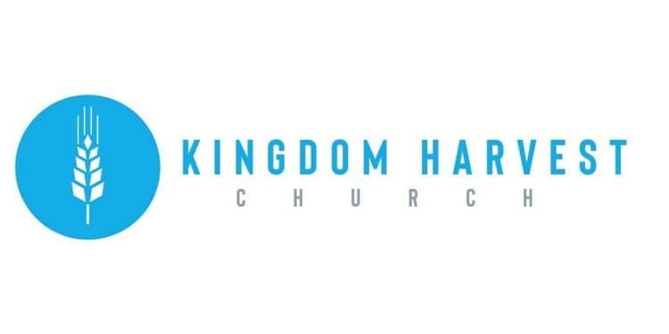

[***https://www.khchurch.com***](https://www.khchurch.com)

***Growing Families.***

***Harvesting the Kingdom.***

**Pastors Tom & Cristy Canterbury**

***PO Box 545***

***Lenore, WV 25676***

***304-475-3805***

**November 14, 2021**

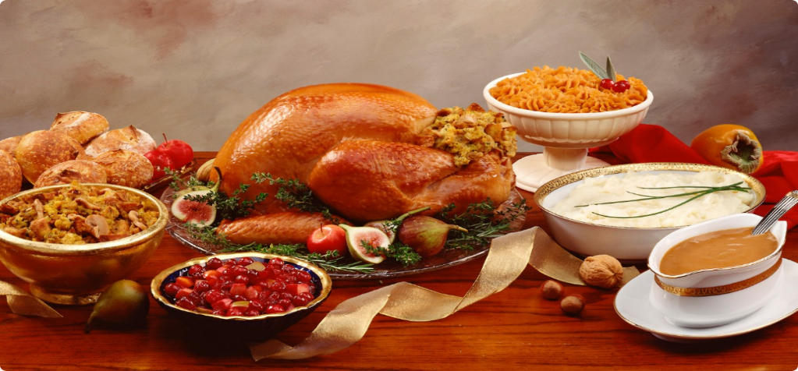

**Welcome to Kingdom Harvest Church**

Thank you for joining us this morning to worship Jesus!

Freddie Lewis will be bringing the Word of God

Let’s Sing…Let’s Shout…Let’s Dance

For He is worthy of all praise!!!

He is so good to us!!!



**Don’t rush off after church today!**

KHC invites all of you to have Thanksgiving Dinner with us!!

This time of year is a time we stop and reflect on the blessings we all have, in spite of the troubles the world may bring. God, in His gracious mercy and grace, gives us more than we ever deserve...that’s enough to praise His Name forevermore!!

*Now unto him that is able to do exceeding abundantly above all that we ask or think, according to the power that worketh in us*

*Ephesians 3:20*

