

***NOVEMBER***

**Birthdays**

*Lynn Preece 11/03 Lakyn Horn 11/05*

*Caspian Damron 11/08 Gary McComis 11/08*

*Emberly Damron 11/10 Garfield Horn 11/11*

*Cristy Canterbury 11/14 Ezra Smith 11/15*

*Hannah Lucas 11/16 Corbin Damron 11/21*

*Joyce Lucas 11/25*

**Spiritual Birthdays**

*Harold Preece Nov 2004*

**Anniversary**

*Chris & Paige Akers 11/17*

*Garfield & Jennifer Horn 11/23*

*Tommy & Cristy Canterbury 11/24*







***Church Announcements***



**Upcoming events to be announced**

**SERVICE TIMES**

Sunday Teen Group Meeting

9:30 AM

Sunday Morning Service & POWER KIDS

11:00 AM

Wednesday Prayer Service

7:00 PM

**Hey Ladies!**

**6PM – Every 3rd Tuesday**

There are many ways to give at Kingdom Harvest…

1. <https://www.khchurch.com>; click on the “Giving” tab
2. Text **kingdomharvestwv** to77977 & follow instructions
3. Black basket at the front door

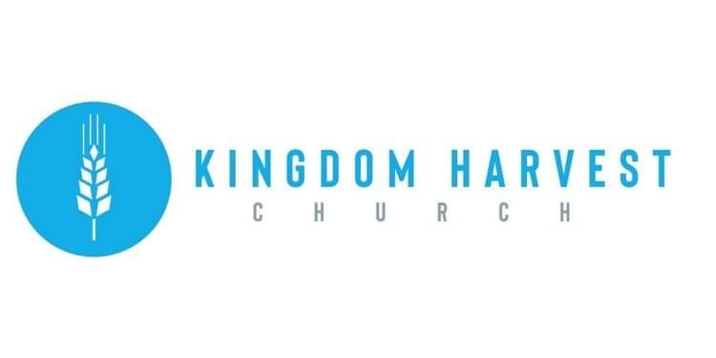

[***https://www.khchurch.com***](https://www.khchurch.com)

***Growing Families.***

***Harvesting the Kingdom.***

**Pastors Tom & Cristy Canterbury**

***PO Box 545***

***Lenore, WV 25676***

***304-475-3805***

**November 7, 2021**

**Greater love hath no man than this, that a man lay down his life for his friends.**

**John 15:13**

Welcome to Kingdom Harvest Church

Thank you for joining us this morning to worship Jesus!

We are having church tonight @ 6pm!!

Invite your friends!

Invite your family!

God is so good…we just want to praise Him!

See you this evening!!









***Remembering our Veterans...***