

***SEPTEMBER & OCTOBER***

**Birthdays**

Brionna Shrum 09/09

Leonard Lucas 09/15

Harold Preece 09/15

Kayleigh Horn 09/18

Esther Grace Lucas 09/29

Kylee Reed 10/03

Christie Reed 10/04

**Spiritual Birthdays**

Tommy Canterbury 09/25

Anna Canterbury 10/09

Tom Canterbury 10/18

**Anniversary**

Danny & Patty Davis 09/07

Ricky & Kayla Hundley 09/13

Tom & Debra Canterbury 10/11

Leonard & Joyce Lucas 10/23







***Church Announcements***



**October 31 – Dennis Heber**

**November 3 – Josh Gwinnup**

**SERVICE TIMES**

Sunday Teen Group Meeting

9:30 AM

Sunday Morning Service & POWER KIDS

11:00 AM

Wednesday Prayer Service

7:00 PM

**Hey Ladies!**

**6PM – Every 3rd Tuesday**

There are many ways to give at Kingdom Harvest…

1. <https://www.khchurch.com>; click on the “Giving” tab
2. Text **kingdomharvestwv** to77977 & follow instructions
3. Black basket at the front door



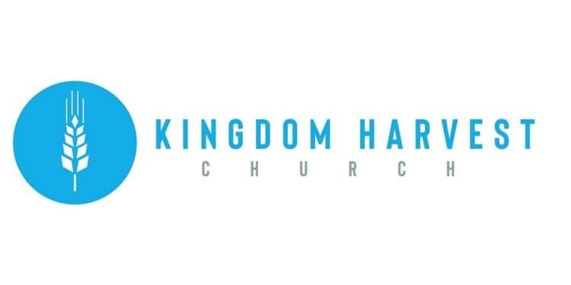

**We Love You Pastor Tommy & Cristy!!**

[***https://www.khchurch.com***](https://www.khchurch.com)

***Growing Families.***

***Harvesting the Kingdom.***

**Pastors Tom & Cristy Canterbury**

***PO Box 545***

***Lenore, WV 25676***

***304-475-3805***

**October 31, 2021**

Wednesday Night, November 3rd KHC will have a special speaker…Josh Gwinnup!

Josh lives in Mira Mesa, Ca, with his wife Chrystal and their 8 children. Josh co-pastored a church in Des Moines, IA that was planted by his Great-Grandfather during the 1950’s Latter Rain movement. Josh travels all over the US ministering in local churches & conferences. He also teaches short-sermons on FB Live & YouTube.

You can find him on the web @ [www.kingdomofgodwithin.org](http://www.kingdomofgodwithin.org) .

**Kingdom Harvest Church**

**Honors**

**Pastor Tommy & Cristy!!**

Since December 2007, Tommy & Cristy Canterbury have been Senior Pastors at KHC. They, and their children-Israel, Anna, & Tori- are a light and inspiration to us all. Pastor Tommy shares the Gospel with such profound wisdom and zeal. He shows his love for the church by obeying God’s voice, listening to God’s wisdom, and being real with the congregation. Pastor Tommy puts in long hours at his “day” job, but, his dedication to the church shows that he puts in longer hours for his flock. Pastor Cristy is ever ready to encourage the members with her smile, her laugh, and her love for God. We are truly blessed to have them as Pastors.

And where, you may ask, did this fire for God originate from? Pastor Tom and Debbie Canterbury!! Pastor Tom’s vision for KHC came to be because of his obedience to God. His passion for God’s work did not stop when he passed the torch to his son. Tom’s passion for the Gospel is strong and God has blessed him with wisdom. Pastor Debbie is such a sweet, loving, caring soul that shines with God’s love!

So today, let them know how much you appreciate them! Give them a hug! A high five! Wave! Tell them how much you appreciate them!

Praise the Lord-give God the praise & glory!

That’s what they want would…for you to praise to Jesus for all He has done!!



