

**AUGUST**

**Birthdays**

Shawn “Spud” Reed 08/12

Carmen Ooten 08/14

Ezekial Smith 08/20

Tommy Canterbury 08/22

Justin Shrum 08/22

Debra Canterbury 08/25

**Spiritual Birthdays**

Lynn Preece 08/03

Leonard Lucas 08/08

Lakyn Horn 08/17

Kaleigh Horn 08/17

**Anniversary**

Corbin & Emberly Damron 08/08

Shawn “Spud” & Christie Reed 08/25

**August is…**









Don’t see your name here… give your info to Angie McComis

We all will join in celebrating your special days!!

***Church Announcements***

***August 22nd – Dennis Heber***

**SERVICE TIMES**

Sunday Teen Group Meeting

9:30 AM

Sunday Morning Service & POWER KIDS

11:00 AM

Wednesday Prayer Service

7:00 PM

There are many ways to give at Kingdom Harvest…

1. <https://www.khchurch.com>; click on the “Giving” tab
2. Text **kingdomharvestwv** to77977 & follow instructions
3. Black basket at the front door



[***https://www.khchurch.com***](https://www.khchurch.com)

***Growing Families.***

***Harvesting the Kingdom.***

**Pastors Tom & Cristy Canterbury**

***PO Box 545***

***Lenore, WV 25676***

***304-475-3805***

**August 22, 2021**

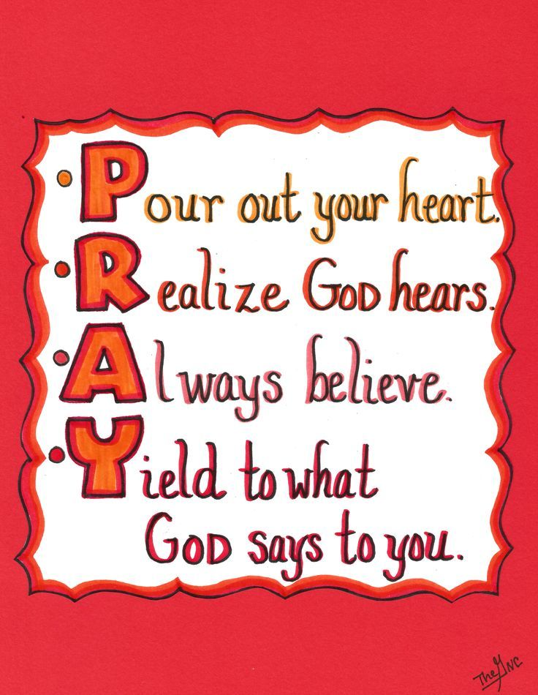

**HUMOR**

Q: Did you know that they had automobiles in Jesus’ time?

A: Yes, the Bible says that the disciples were all of one Accord.

In the beginning, God created the earth and rested.

Then God created Man and rested.

Then God created Woman.

Since then, neither God nor Man has rested.

Billy had been misbehaving and was sent to his room. After a while he emerged and informed his mother that he had thought it over and then said a prayer. “Fine,” said the pleased mother. “If you ask God to help you not misbehave, He will help you.” “Oh, I didn’t ask Him to help me not misbehave,” said Billy. “I asked Him to help you put up with me.”

Father O’Malley answers the phone.

“Hello, is this Father O’Malley?”

“It is.”

“This is the IRS. Can you help us?”

“I can.”

“Do you know a Ted Houlihan?”

“I do.”

“Is he a member of your congregation?”

“He is.”

“Did he donate $10,000 to the church?”

“He will.”

Little Johnny’s new baby brother was screaming up a storm.

Johnny asked his mom. “Where’d he come from?”

“He came from Heaven, Johnny.”

Johnny responded. “Wow! I can see why they threw him out!”

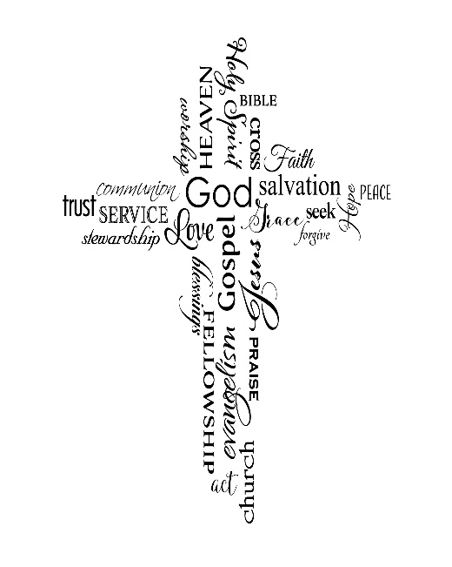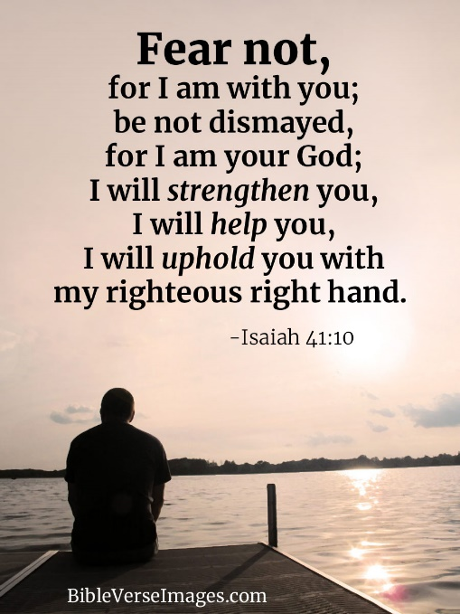



Happy Birthday Pastor Tommy!!

We Love You!!