

**AUGUST**

**Birthdays**

Shawn “Spud” Reed 08/12

Carmen Ooten 08/14

Ezekial Smith 08/20

Tommy Canterbury 08/22

Justin Shrum 08/22

Debra Canterbury 08/25

**Spiritual Birthdays**

Lynn Preece 08/03

Leonard Lucas 08/08

Lakyn Horn 08/17

Kaleigh Horn 08/17

**Anniversary**

Corbin & Emberly Damron 08/08

Shawn “Spud” & Christie Reed 08/25

**August is…**









Don’t see your name here… give your info to Angie McComis

We all will join in celebrating your special days!!

***Church Announcements***

***August 8th – Graduate Cookout @ Pastors’ house***

***August 22nd – Dennis Heber***

**SERVICE TIMES**

Sunday Teen Group Meeting

9:30 AM

Sunday Morning Service & POWER KIDS

11:00 AM

Wednesday Prayer Service

7:00 PM

There are many ways to give at Kingdom Harvest…

1. <https://www.khchurch.com>; click on the “Giving” tab
2. Text **kingdomharvestwv** to77977 & follow instructions
3. Black basket at the front door

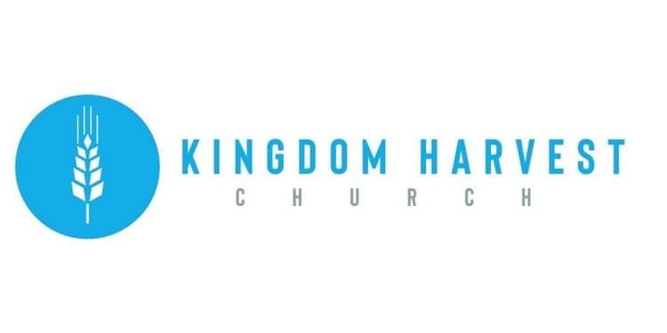

[***https://www.khchurch.com***](https://www.khchurch.com)

***Growing Families.***

***Harvesting the Kingdom.***

**Pastors Tom & Cristy Canterbury**

***PO Box 545***

***Lenore, WV 25676***

***304-475-3805***

**August 08, 2021**

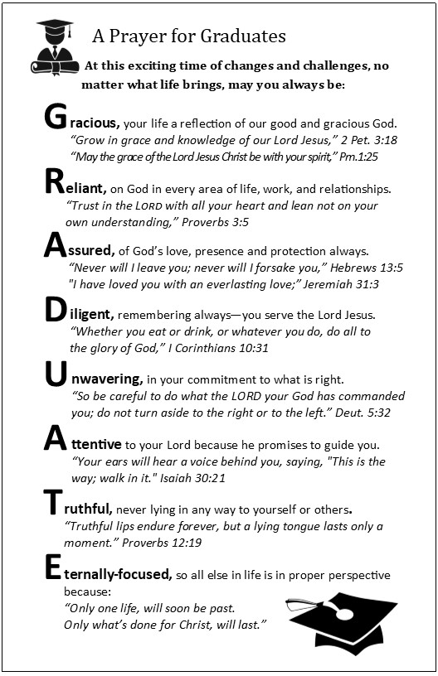

***Investing in What Matters More to You*** …that was the title of the message from Corbin Damron this past Wednesday. No, this was not a message about tithing, though it does hold true for this. The message dealt with how we spend our time, how we make time for the things that matters most to us, and what we should be spending our time on.

As our graduates begin a new chapter in their lives, it is the perfect “time” for them to reflect on how their “time” should be spent to achieve their goals in the next phase of their lives. “Anything you have faith in, you spend time and money on.” Corbin Damron. This rings so true of all of us. Even if you aren’t a graduate, take some “time” to reflect on where most of your “time” is spent!

God Bless our Graduates!!



**KHC Celebrates our 2020-2021 Graduates**

***What:*** Cook Out (food is always needed for celebrating!!)

***When:*** August 8, 2021(gives us time to prepare…)

***Where:*** Pastor Tom’s house (Ain’t he the greatest?☺) If you don’t know the way, follow the person in front of you.

***Time:*** After Sunday morning service **today**

***RSVP:*** So he’ll know how many to grill for (ha-ha)

***Who’s Invited:*** All of ya…and the graduates, too!