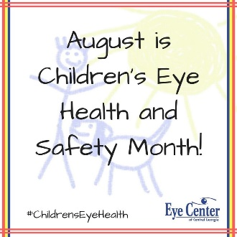

**AUGUST**

**Birthdays**

Shawn “Spud” Reed 08/12

Carmen Ooten 08/14

Ezekial Smith 08/20

Tommy Canterbury 08/22

Justin Shrum 08/22

Debra Canterbury 08/25

**Spiritual Birthdays**

Lynn Preece 08/03

Leonard Lucas 08/08

Lakyn Horn 08/17

Kaleigh Horn 08/17

**Anniversary**

Corbin & Emberly Damron 08/08

Shawn “Spud” & Christie Reed 08/25

**August is…**

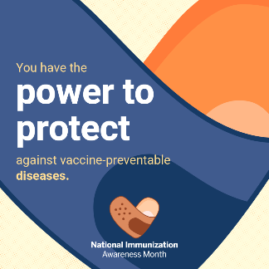







Don’t see your name here… give your info to Angie McComis

We all will join in celebrating your special days!!

***Church Announcements***

***August 8th – Graduate Cookout @ Pastors’ house***

***August 22nd – Dennis Heber***

**SERVICE TIMES**

Sunday Teen Group Meeting

9:30 AM

Sunday Morning Service & POWER KIDS

11:00 AM

Wednesday Prayer Service

7:00 PM

There are many ways to give at Kingdom Harvest…

1. <https://www.khchurch.com>; click on the “Giving” tab
2. Text **kingdomharvestwv** to77977 & follow instructions
3. Black basket at the front door

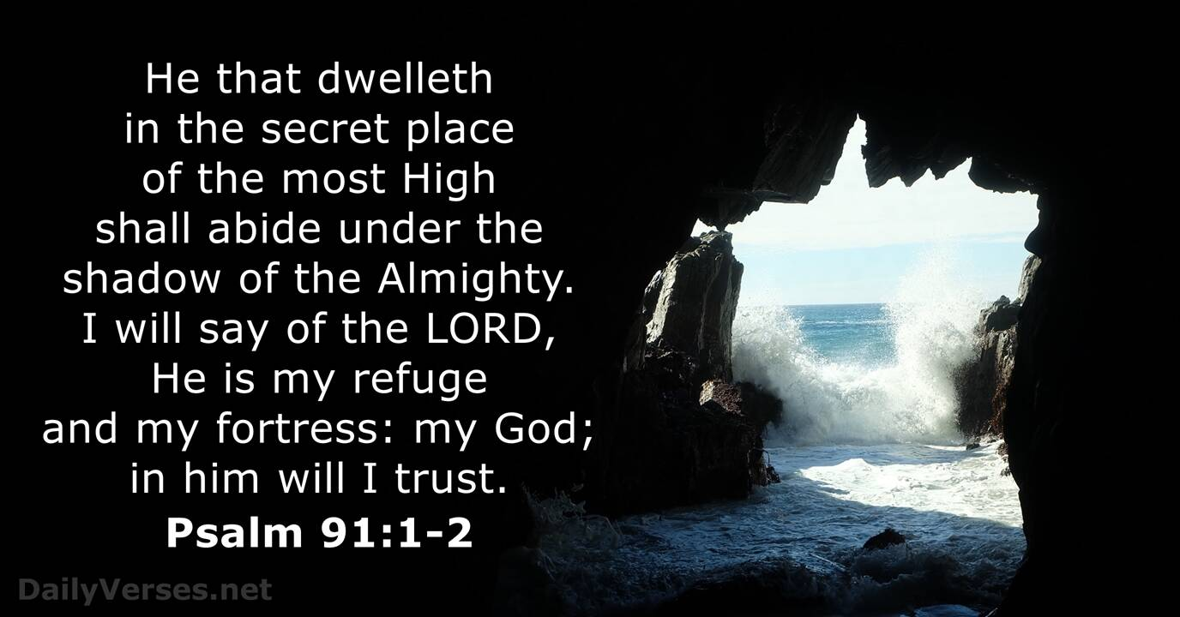

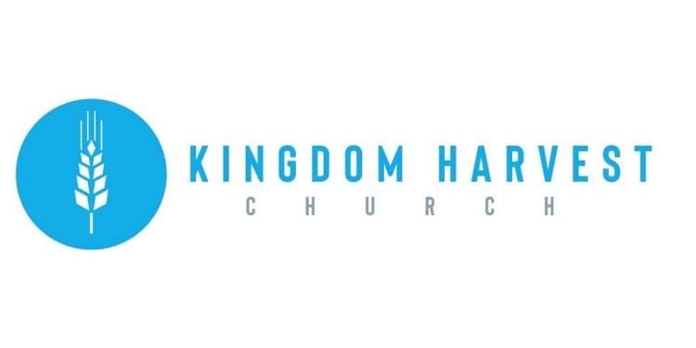

[***https://www.khchurch.com***](https://www.khchurch.com)

***Growing Families.***

***Harvesting the Kingdom.***

**Pastors Tom & Cristy Canterbury**

***PO Box 545***

***Lenore, WV 25676***

***304-475-3805***

**August 01, 2021**

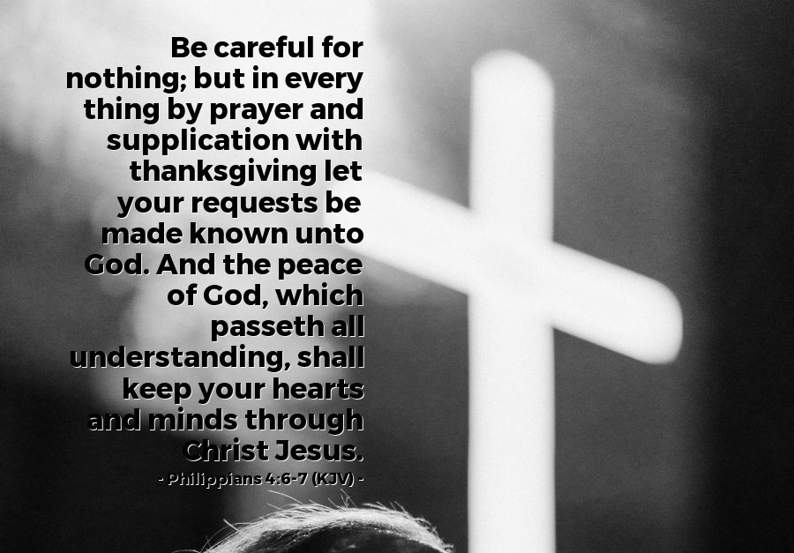

*Me: Hey God.*  
  
**God: Hello, my love.**   
  
*Me: I'm falling apart. Can you put me back together?*  
**God: I would rather not.**   
  
*Me: Why?*  
  
**God: Because you aren't a puzzle.**   
  
*Me: What about all of the pieces of my life that are falling down onto the ground?*   
  
**God: Let them stay there for a while. They fell off for a reason. Take some time and decide if you need any of those pieces back.**   
  
*Me: You don't understand! I'm breaking down!*   
  
**God: No - you don't understand. You are breaking through. What you are feeling are just growing pains. You are shedding the things and the people in your life that are holding you back. You aren't falling apart. You are falling into place. Relax. Take some deep breaths and allow those things you don't need any more to fall off of you. Quit holding onto the pieces that don't fit you anymore. Let them fall off. Let them go.**   
  
*Me: Once I start doing that, what will be left of me?*   
  
**God: Only the very best pieces of you.**   
  
*Me: I'm scared of changing.*  
  
**God: I keep telling you - YOU AREN'T CHANGING!! YOU ARE BECOMING!**  
  
*Me: Becoming who?*   
  
**God: Becoming who I created you to be! A person of light and love and charity and hope and courage and joy and mercy and grace and compassion. I made you for more than the shallow pieces you have decided adorn yourself with that you cling to with such greed and fear. Let those things fall off of you. I love you! Don't change! Become! Become! Become! Become who I made you to be. I'm going to keep telling you this until you remember it.**   
  
*Me: There goes another piece.*   
  
**God: Yep. Let it be.**   
  
*Me: So...I'm not broken?*   
  
**God: No - but you are breaking like the dawn. It's a new day. Become!! Become!!**  
  
Author ~ John Roedel





**KHC Celebrates our 2020-2021 Graduates**

***What:*** Cook Out (food is always needed for celebrating!!)

***When:*** August 8, 2021(gives us time to prepare…)

***Where:*** Pastor Tom’s house (Ain’t he the greatest?☺) If you don’t know the way, follow the person in front of you.

***Time:*** After Sunday morning service (of course!)

***RSVP:*** So he’ll know how many to grill for (ha-ha)

***Who’s Invited:*** All of ya…and the graduates, too!