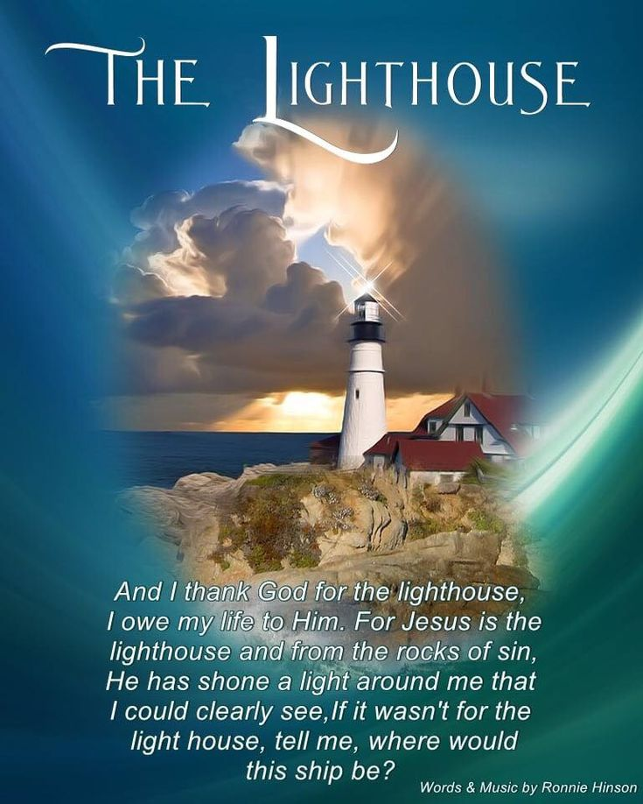

**July is…**

**JULY**

**Birthdays**

Hayden Ball 07/16

Judy Adkins 07/17

Dan Smith 07/18

Patty Davis 07/31

Tammy Salmons 07/31

**Spiritual Birthdays**

Debra Canterbury – July

Corbin Damron 07/17

Gary McComis 07/28

**Anniversary**

Gary & Rose Canterbury 07/02





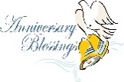

Don’t see your name here… give your info to Angie McComis

We all will join in celebrating your special days!!



***Church Announcements***

***August 8th – Graduate Cookout @ Pastors’ house***

***August 22nd – Dennis Heber***

**SERVICE TIMES**

Sunday Teen Group Meeting

9:30 AM

Sunday Morning Service & POWER KIDS

11:00 AM

Wednesday Prayer Service

7:00 PM

There are many ways to give at Kingdom Harvest…

1. <https://www.khchurch.com>; click on the “Giving” tab
2. Text **kingdomharvestwv** to77977 & follow instructions
3. Black basket at the front door

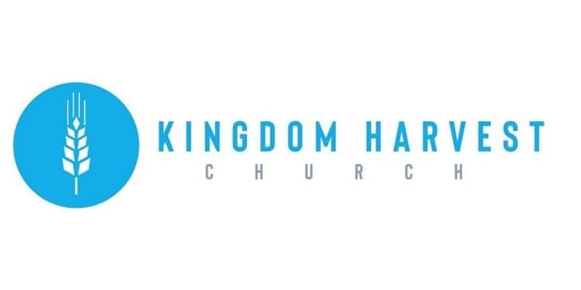

[***https://www.khchurch.com***](https://www.khchurch.com)

***Growing Families.***

***Harvesting the Kingdom.***

**Pastors Tom & Cristy Canterbury**

***PO Box 545***

***Lenore, WV 25676***

***304-475-3805***

**July 25, 2021**

Wednesday Night Teaching continues…Pastor Tommy is continuing teaching on “Gifts of the Spirit”. Before this series of teaching, Pastor Tommy taught on “Why Speaking in Tongues”. The first of this series began July 14th. The text used was 1st Corinthians 12. Pastor Tommy encourages all to come and learn about the nine “gifts of the Spirit”.

There are 3 Revelation Gifts:

* Word of Wisdom
* Word of Knowledge
* Discernment of spirits

There are 3 Power Gifts:

* Faith
* Working of Miracles
* Healings

There are 3 Utterance Gifts:

* Tongues
* Interpretation of Tongues
* Prophecy

*There's a lighthouse on the hillside that overlooks life's sea.*

*When I'm tossed it sends out a light, tis a light that I might see.*

*And the light that shines in darkness now will safely lead us o'er.*

*If it wasn't for the lighthouse, my ship would be no more.*

**CHORUS**

*And I thank God for the lighthouse, I owe my life to Him.*

*For Jesus is the lighthouse and from the rocks of sin;*

*He has shone a light around me that I could clearly see,*

*If it wasn't for the lighthouse tell me where would this ship be.*

*Everybody that lives around us says tear that lighthouse down.*

*The big ships don't sail this way anymore, there's no use of it standing around.*

*Then my mind goes back to that stormy night, when just in time I saw the light;*

*Yes the light from that old lighthouse that stands up there on the hill.*

**CHORUS**

*And I thank God for the lighthouse, I owe my life to Him.*

*For Jesus is the lighthouse and from the rocks of sin;*

*He has shone a light around me that I could clearly see,*

*If it wasn't for the lighthouse tell me where would this ship be.*

*If it wasn't for the lighthouse, tell me, where would this ship be?*

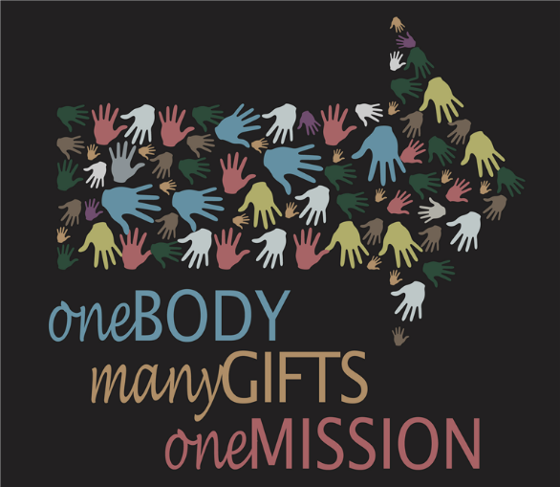

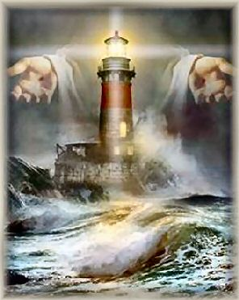

**KHC Celebrates our 2020-2021 Graduates**

***What:*** Cook Out (food is always needed for celebrating!!)

***When:*** August 8, 2021(gives us time to prepare…)

***Where:*** Pastor Tom’s house (Ain’t he the greatest?☺) If you don’t know the way, follow the person in front of you.

***Time:*** After Sunday morning service (of course!)

***RSVP:*** So he’ll know how many to grill for (ha-ha)

***Who’s Invited:*** All of ya…and the graduates, too!