

**July is…**

**JULY**

**Birthdays**

Hayden Ball 07/16

Judy Adkins 07/17

Patty Davis 07/31

Tammy Salmons 07/31

**Spiritual Birthdays**

Debra Canterbury – July

Corbin Damron 07/17

Gary McComis 07/28

**Anniversary**

Gary & Rose Canterbury 07/02







Don’t see your name here… give your info to Angie McComis

We all will join in celebrating your special days!!



**Church Announcements**

**SERVICE TIMES**

Sunday Teen Group Meeting

9:30 AM

Sunday Morning Service & POWER KIDS

11:00 AM

Wednesday Prayer Service

7:00 PM

There are many ways to give at Kingdom Harvest…

1. <https://www.khchurch.com>; click on the “Giving” tab
2. Text **kingdomharvestwv** to77977 & follow instructions
3. Black basket at the front door

And all things, whatsoever ye shall ask in prayer, believing, ye shall receive. ***Matthew 21:22***

Ma



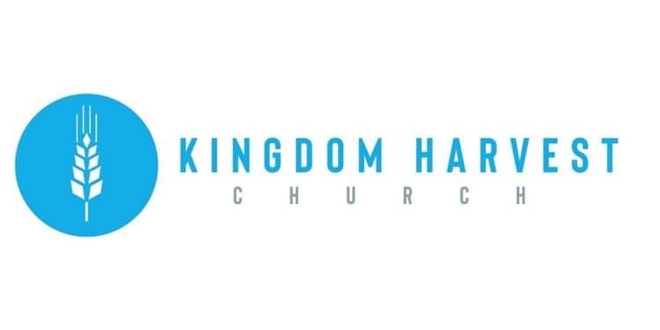

[***https://www.khchurch.com***](https://www.khchurch.com)

***Growing Families.***

***Harvesting the Kingdom.***

**Pastors Tom & Cristy Canterbury**

***PO Box 545***

***Lenore, WV 25676***

***304-475-3805***

**July 18, 2021**



**July is National Ice Cream Month!!**

**What better way to celebrate than to have ice cream with family!!**

**KHC Family**

**Sundae July 18, 2021**

**We are having an old-fashioned Ice Cream Social…**

**So grab a spoon, scoop, and your favorite flavor!**

**It’s Party Time!!**

**Y U M M Y!!!**





**KHC**

**welcomes**

**Dennis Heber!!**

**KHC Celebrates our 2020-2021 Graduates**

***What:*** Cook Out (food is always needed for celebrating!!)

***When:*** August 8, 2021(gives us time to prepare…)

***Where:*** Pastor Tom’s house (Ain’t he the greatest?☺) If you don’t know the way, follow the person in front of you.

***Time:*** After Sunday morning service (of course!)

***RSVP:*** So he’ll know how many to grill for (ha-ha)

***Who’s Invited:*** All of ya…and the graduates, too!