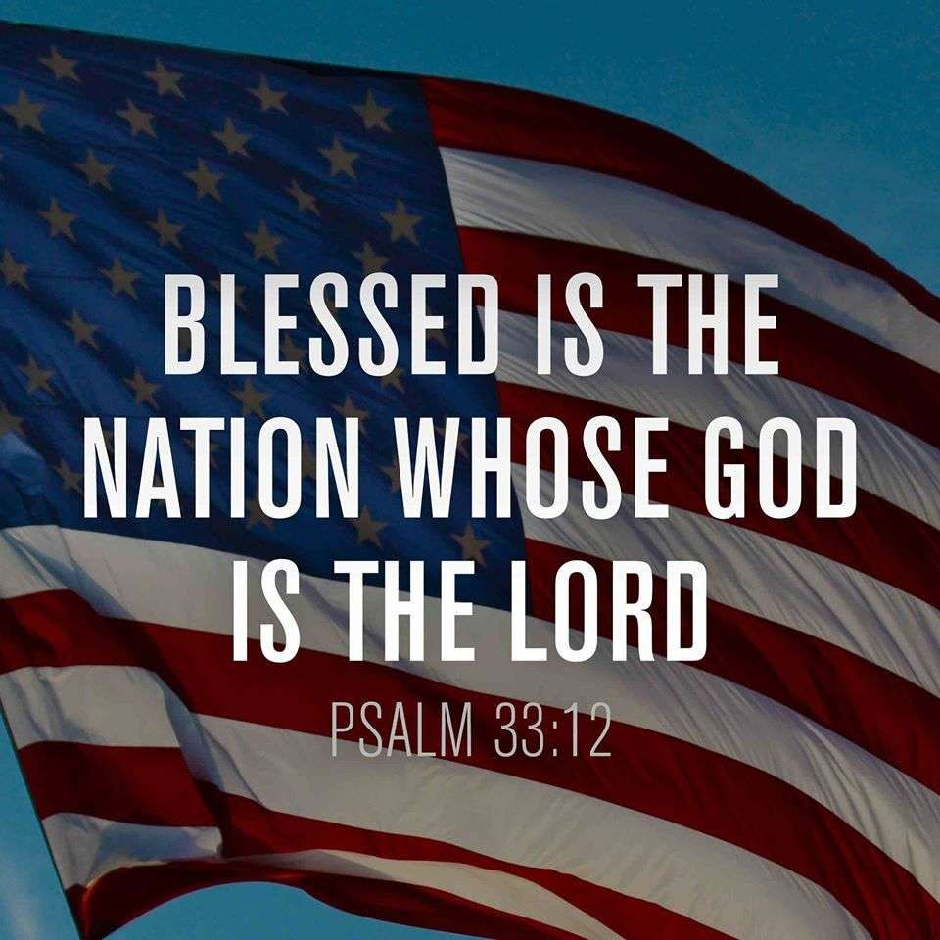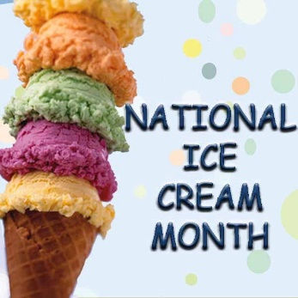

**July is…**

**JULY**

**Birthdays**

Hayden Ball 07/16

Judy Adkins 07/17

**Spiritual Birthdays**

Debra Canterbury – July

Corbin Damron 07/17

Gary McComis 07/28

**Anniversary**

Gary & Rose Canterbury 07/02







Don’t see your name here… give your info to Angie McComis

We all will join in celebrating your special days!!



**Church Announcements**



**SERVICE TIMES**

Sunday Teen Group Meeting

9:30 AM

Sunday Morning Service & POWER KIDS

11:00 AM

Wednesday Prayer Service

7:00 PM

**July 4th** – Independence Day



There are many ways to give at Kingdom Harvest…

1. <https://www.khchurch.com>; click on the “Giving” tab
2. Text **kingdomharvestwv** to77977 & follow instructions
3. Black basket at the front door

**Jesus is the reason we are free!!**

**Pastors Tom & Cristy Canterbury**

***PO Box 545***

***Lenore, WV 25676***

***304-475-3805***

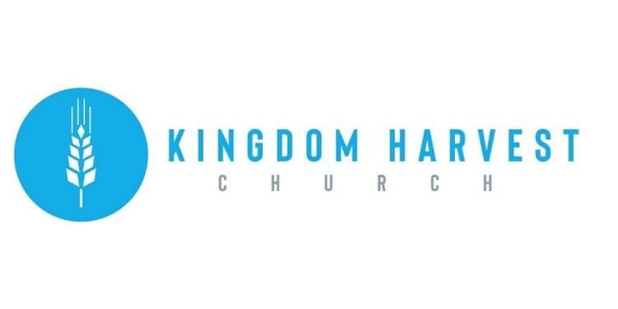

[***https://www.khchurch.com***](https://www.khchurch.com)

***Growing Families.***

***Harvesting the Kingdom.***

**July 4, 2021**

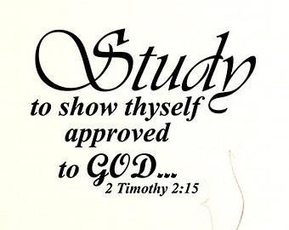

# **A PRAYER FOR INDEPENDENCE DAY**

***Mighty God!***

*You are to be desired by all nations, yet You gave great freedom to this country. With celebration for our nation’s birth, I come before You with thanksgiving for the freedom bestowed on me each day anew. Praise be to the Lord who granted and preserves our independence! From our earliest days, You have made us a nation of strength and compassion because we sought your favor. John Adams was right when he wrote of Independence Day, saying: “It ought to be commemorated, as the day of deliverance, by solemn acts of devotion to God Almighty.”*

*Have we forgotten that You are our deliverer, refuge, and fortress? It is You alone, our Creator, who endows us with the right to the life, liberty, and the pursuit of happiness our Declaration of Independence speaks of. True freedom is not granted by a piece of paper, but through the sacrifice of Jesus Christ, our Savior: Let us be forever watchful of our hearts that we may not blindly fall into the slavery of sin and pride. Instead, let the skies above our land be a reminder of your hand in creation.4 Let their beauty direct us, with thankful spirits, toward Your will in America. Let us embrace the words spoken by Samuel Adams as the Declaration of Independence was being signed:*

*“We have this day restored the Sovereign to Whom all men ought to be obedient. He reigns in heaven and from the rising to the setting of the sun, let His kingdom come.”*

*On this Independence Day, we do not celebrate our own accomplishments, but Yours through us. May you receive the glory for America’s greatness, and may we be faithful stewards of Your gospel to the nations.*

*AMEN*

<https://joshuajmasters.com/a-prayer-for-independence-day-2019/>

Have you heard what’s been happening on Wednesday nights?

Pastor Tommy is teaching a series on Speaking in Tongues. This series began the last week in May. Each week, the teaching gets a little deeper into the reason for the “gift of speaking in tongues”. At the end of the series, Pastor Tommy will have a special prayer service for those who want this experience.

Come and join us in learning more about God’s Word!!

