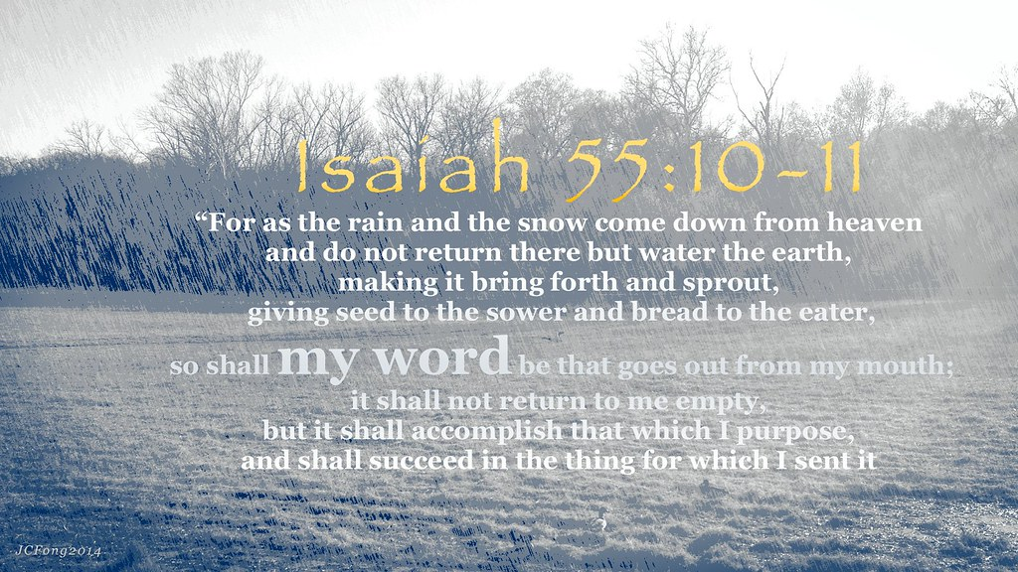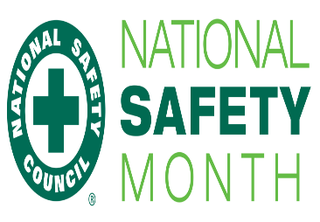

**June is…**

**JUNE**

**Birthdays**

Stacy Ball 06/01

Kyla Smith 06/02

Austin Horn 06/03

Victoria Canterbury 06/25

Bob Adkins 06/26

**Spiritual Birthdays**

Bob & Judy Adkins 06/06

Victoria Canterbury 06/06

**Anniversary**

Neil & Stacy Ball 06/04

Brandon & Kimmy Vance 06/08

Harold & Lynn Preece 06/16

Tyler & Hannah Lucas 06/24





Don’t see your name here… give your info to Angie McComis

We all will join in celebrating your special days!!



**Church Announcements**

**June 27th** – Dennis Heber Speaking

**July 4th** – Independence Day

**SERVICE TIMES**

Sunday Teen Group Meeting

9:30 AM

Sunday Morning Service & POWER KIDS

11:00 AM

Wednesday Prayer Service

7:00 PM



There are many ways to give at Kingdom Harvest…

1. <https://www.khchurch.com>; click on the “Giving” tab
2. Text **kingdomharvestwv** to77977 & follow instructions
3. Black basket at the front door

**Don’t just invite people to church.**

Invite them to lunch

Invite them to your table or patio

Invite them into your life!

***Be there for them.***

**We –**

**not our building**

**– are the church!**

**Pastors Tom & Cristy Canterbury**

***PO Box 545***

***Lenore, WV 25676***

***304-475-3805***



[***https://www.khchurch.com***](https://www.khchurch.com)

***Growing Families.***

***Harvesting the Kingdom.***

**June 27, 2021**



***Recreational Boating: Stay Safe on the Water***

**Life Jackets Are Essential!!**

* Make sure the jacket is a proper fit for your size and weight
* Make sure the jacket is properly fastened
* Hold your arms straight up over your head, ask a friend to grasp the tops of the arm openings and gently pull up; make sure there is no excess room above the openings and that the jacket does not ride up over your chin or face

**Be Prepared!!**

* Check that your equipment is in good working order
* Ensure you have everything you need in your boat, including a tool kit and first-aid kit
* Don’t forget the sunscreen and know the signs of heat illnesses

**Exercise Good Judgement!!**

* Respect your limits and keep within your limits to avoid injury
* Once on the water, use common sense; in a split second, a situation can arise or the weather can turn
* If you notice storm clouds, a sudden temperature drop or wind speed increasing, play it safe & get off the water

**Safety Tips for Water Skiers, Tubers, & Wakeboarders!!**

* Learn how to get up out of the water and how to safely use the tow rope
* Always have a spotter in the boat, and go over basic hand signals
* Make certain the towline is not caught in the propeller or wrapped around you prior to beginning
* Wait for the propeller to stop before getting back on the boat
* Enjoy these activities during daylight hours only

# *The Peace Prayer -Saint Francis*

*Lord, make me an instrument of your peace.  
Where there is hatred, let me sow love;  
Where there is error, truth;  
Where there is injury, pardon;  
Where there is doubt, faith;  
Where there is despair, hope;   
Where there is darkness, light;  
And where there is sadness, joy.*

*O Divine Master, grant that I may not so much seek  
To be consoled as to console;  
To be understood as to understand;  
To be loved as to love.  
For it is in giving that we receive;  
It is in pardoning that we are pardoned;  
It is in self-forgetting that we find;  
And it is in dying to ourselves that we are born to eternal life.  
Amen.*

