

**June is…**

**JUNE**

**Birthdays**

Stacy Ball 06/01

Kyla Smith 06/02

Austin Horn 06/03

Victoria Canterbury 06/25

Bob Adkins 06/26

**Spiritual Birthdays**

Bob & Judy Adkins 06/06

Victoria Canterbury 06/06

**Anniversary**

Neil & Stacy Ball 06/04

Brandon & Kimmy Vance 06/08

Harold & Lynn Preece 06/16

Tyler & Hannah Lucas 06/24





Don’t see your name here… give your info to Angie McComis

We all will join in celebrating your special days!!





**Pastors Tom & Cristy Canterbury**

***PO Box 545***

***Lenore, WV 25676***

***304-475-3805***

**And we know that all things work together for good to them that love God, to them who are called according to His purpose**

**Romans 8:28**

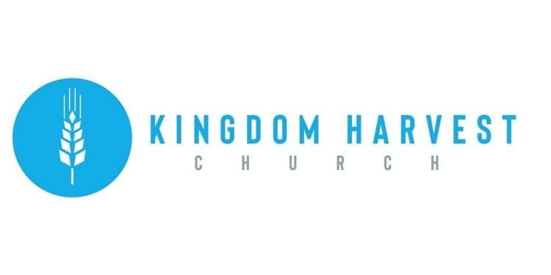

[***https://www.khchurch.com***](https://www.khchurch.com)

***Growing Families.***

***Harvesting the Kingdom.***

**June 13, 2021**



**June 20th** – Father’s Day

**June 27th** – Dennis Heber Speaking

**July 4th** – Independence Day

**Church Announcements**



**God’s Promise**

And the bow shall be in the cloud; and I will look upon it, that I may remember that everlasting covenant between God and every living creature of all flesh that is upon the earth.

**Genesis 9:16**

Grass-Cutting Schedule

**REMINDER: If you would like to help with lawn care at KHC contact Leonard Lucas or Harold Preece.**

There are many ways to give at Kingdom Harvest…

1. <https://www.khchurch.com>; click on the “Giving” tab
2. Text **kingdomharvestwv** to77977 & follow instructions
3. Black basket at the front door

**SERVICE TIMES**

Sunday Teen Group Meeting

9:30 AM

Sunday Morning Service & POWER KIDS

11:00 AM

Wednesday Prayer Service

7:00 PM