

**June is…**

**JUNE**

**Birthdays**

Stacy Ball 06/01

Kyla Smith 06/02

Austin Horn 06/03

Victoria Canterbury 06/25

Bob Adkins 06/26

**Spiritual Birthdays**

Bob & Judy Adkins 06/06

Victoria Canterbury 06/06

**Anniversary**

Neil & Stacy Ball 06/04

Brandon & Kimmy Vance 06/08

Harold & Lynn Preece 06/16

Tyler & Hannah Lucas 06/24





Don’t see your name here… give your info to Angie McComis

We all will join in celebrating your special days!!



“**Blessings Box**”

The Box is available to **ALL** that may need some food or non-perishable items.

KHC will be responsible for supplying non-perishable food and hygiene items each week.

Help KHC spread the Word about this wonderful addition

**“Growing Families**

**Harvesting the Kingdom”**



**Pastors Tom & Cristy Canterbury**

***PO Box 545***

***Lenore, WV 25676***

***304-475-3805***

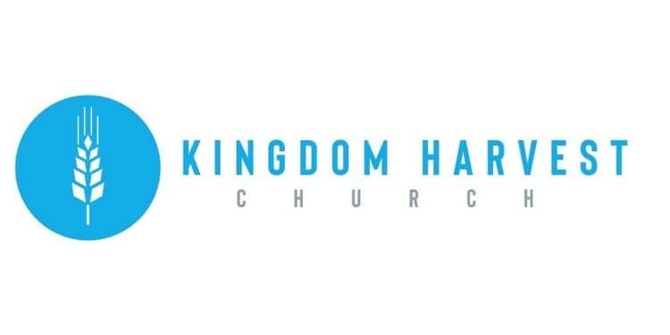

**June 6, 2021**



[***https://www.khchurch.com***](https://www.khchurch.com)

***Growing Families.***

***Harvesting the Kingdom.***



**June 6th** – Membership Sunday

**June 20th** – Father’s Day

**June 27th** – Dennis Heber Speaking

**Church Announcements**

**Today at KHC, the church doors will be open for new members. Though membership is not a requirement at KHC (as explained in the handout included with this bulletin) we welcome all our new members!!**



Grass-Cutting Schedule

**REMINDER: If you would like to help with lawn care at KHC contact Leonard Lucas or Harold Preece.**

There are many ways to give at Kingdom Harvest…

1. <https://www.khchurch.com>; click on the “Giving” tab
2. Text **kingdomharvestwv** to77977 & follow instructions
3. Black basket at the front door

**SERVICE TIMES**

Sunday Teen Group Meeting

9:30 AM

Sunday Morning Service & POWER KIDS

11:00 AM

Wednesday Prayer Service

7:00 PM