********

**MAY**

**Birthdays**

Lilah-Belle Damron 05/07

Hunter Shrum 05/18

**Spiritual Birthdays**

Neil & Stacy Ball *May 2010*

**Anniversary**

Dan & Kyla Smith 05/29







KHC now has a “**Blessings Box**”!!

This is another way to spread the Good News about God’s love for His people…the Box is available to ALL that may need some food. The Box is available per a grant from the Town of Delbarton & Marshall University. KHC will be responsible for supplying non-perishable food and hygiene items each week. Help KHC spread the Word about this wonderful addition!

“Growing Families

Harvesting the Kingdom”

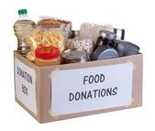



**Pastors Tom & Cristy Canterbury**

***PO Box 545***

***Lenore, WV 25676***

***304-475-3805***

**Kingdom Harvest Church**

**1st Annual “Blessing of the Bikes” Service**

**2021**

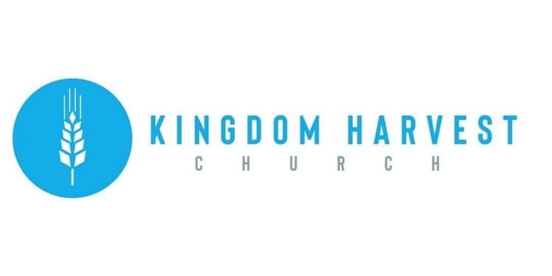

**May 30, 2021**

[***https://www.khchurch.com***](https://www.khchurch.com)

***Growing Families.***

***Harvesting the Kingdom.***





KHC is so happy to see you!!

You are Family here…

Just a quick reminder that next Sunday, June 6th, is “**Membership Sunday**”

See Pastor Tom or Cristy for more details!

**May 30th** – Memorial Day

**June 6th** – Membership Sunday

**Church Announcements**

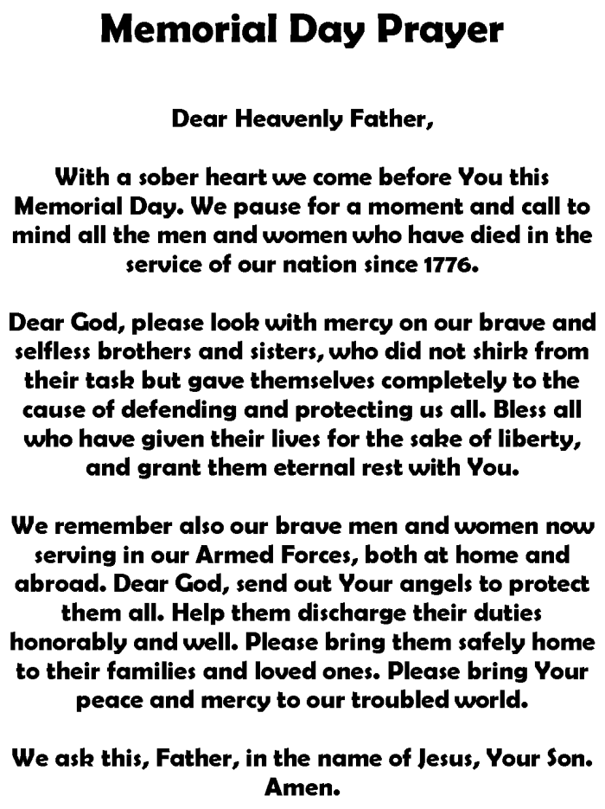

**UPDATE!!**

The carpet for the sanctuary has been chosen and will soon be installed! When giving towards the carpet, make sure to designate in the memo (if writing a check) “Sanctuary Carpet” or, if online, designate Building Fund

**A new commandment I give unto you, That ye love one another; as I have loved you, that ye also love one another.**

**By this shall all men know that ye are my disciples; if you have love one to another.**

**John 13:34-35**

Grass-Cutting Schedule

**REMINDER: If you would like to help with lawn care at KHC contact Leonard Lucas or Harold Preece.**

**SERVICE TIMES**

Sunday Teen Group Meeting

9:30 AM

Sunday Morning Service & POWER KIDS

11:00 AM

Wednesday Prayer Service

7:00 PM

There are many ways to give at Kingdom Harvest…

1. <https://www.khchurch.com>; click on the “Giving” tab
2. Text **kingdomharvestwv** to77977 & follow instructions
3. Black basket at the front door