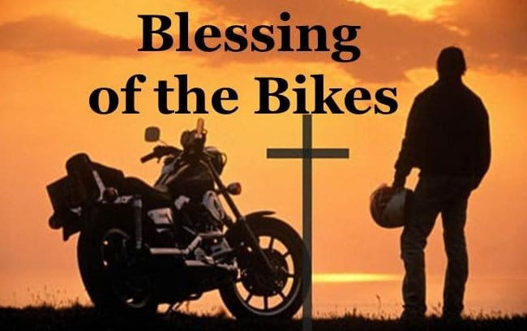****

**MAY**

**Birthdays**

Lilah-Belle Damron 05/07

Hunter Shrum 05/18

**Spiritual Birthdays**

Neil & Stacy Ball *May 2010*

**Anniversary**

Dan & Kyla Smith 05/29







KHC now has a “**Blessings Box**”!!

This is another way to spread the Good News about God’s love for His people…the Box is available to ALL that may need some food. The Box is available per a grant from the Town of Delbarton & Marshall University. KHC will be responsible for supplying non-perishable food and hygiene items each week. Help KHC spread the Word about this wonderful addition!

“Growing Families

Harvesting the Kingdom”

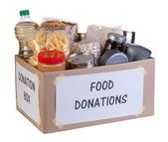



**Pastors Tom & Cristy Canterbury**

***PO Box 545***

***Lenore, WV 25676***

***304-475-3805***

**Kingdom Harvest Church**

**1st Annual “Blessing of the Bikes” Service**

**2021**

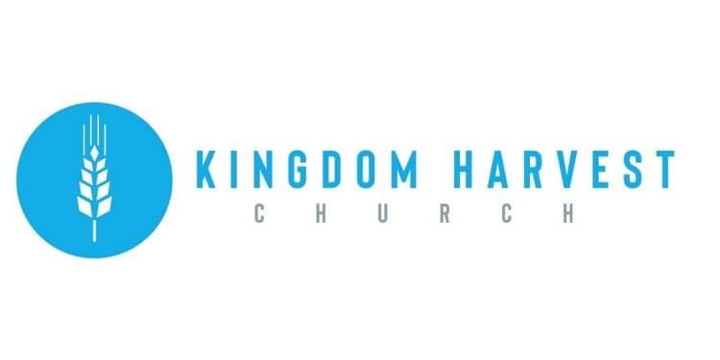

**May 23, 2021**

[***https://www.khchurch.com***](https://www.khchurch.com)

***Growing Families.***

***Harvesting the Kingdom.***





**Protection Prayer**Lord Jesus, without you, we can do nothing.  You are our defender and deliverer, the one who fights all our battles and shields us from every death trap that the enemy has set before us.  Lord, we ask you to cover us under your wings so that we can find refuge as we ride our motorcycles to our various destinations. Be with us always and protect us from careless drivers who may put us in great danger.  In Jesus’ name, we believe and pray, Amen.

**Go Before Us Prayer**Heavenly Father, King of Glory, before we start this journey, we ask you to go before us and clear the roads that we will be using.  Remove every obstacle that may block us from reaching our destination safely.  Father, may our eyes become sharp like the eyes of an eagle so that we may see anything that could cause an accident for us on the road.  Thank you for sending your angels to be with us.  In Jesus’ name, we believe and pray, Amen.

**Safety Prayer**Dear Lord, as we set out on the road this morning, we ask you to protect us from reckless drivers and motorists who do not care about their lives or the lives of other road users. Save us from drunk drivers and bring us home in one piece.  Encompass us with your strength that we may ride safely and reach thousands of people for the glory of your holy name. May everything we do be for your Kingdom and not for our selfish interests. Through Jesus’ name, we believe and pray, Amen.

**After the “RIDE”…We are having a cookout to continue the fellowship!!**

**Hot Dogs…Hamburgers…Pulled Pork…Side Dishes…Desserts!!**

**Come & Get It!!!**

**WELCOME TO THE KINGDOM HARVEST CHURCH 1ST ANNUAL “BLESSING OF THE BIKES” SERVICE**

**We are excited to see you and so glad you here today!!**

Not only do we get to sing praises to Jesus and hear God’s Word, we also will pray for a safe riding season for all riders…motorcycles, dirt bikes, 4-wheelers, side-by-sides, scooters, bicycles…you name it and it’s covered in today’s prayer! *“And all things, whatsoever ye shall ask in prayer, believing, ye shall receive. Matthew 21:22”*

So join us in **Praise!!** **Song!!** **Shout** to the goodness of Christ!! 

Grass-Cutting Schedule

**REMINDER: If you would like to help with lawn care at KHC contact Leonard Lucas or Harold Preece.**

**SERVICE TIMES**

Sunday Teen Group Meeting

9:30 AM

Sunday Morning Service & POWER KIDS

11:00 AM

Wednesday Prayer Service

7:00 PM

**May 23rd** – Blessing of the Bikes Service-Speaker David Rice

**Cookout to follow – Dress in Biker Apparel**

**June 6th** – Membership Sunday

There are many ways to give at Kingdom Harvest…

1. <https://www.khchurch.com>; click on the “Giving” tab
2. Text **kingdomharvestwv** to77977 & follow instructions
3. Black basket at the front door

**Church Announcements**