

**MAY**

**Birthdays**

Lilah-Belle Damron 05/07

Hunter Shrum 05/18

**Spiritual Birthdays**

Neil & Stacy Ball *May 2010*

**Anniversary**

Dan & Kyla Smith 05/29



Blessings of the Bikes

May 23, 2021





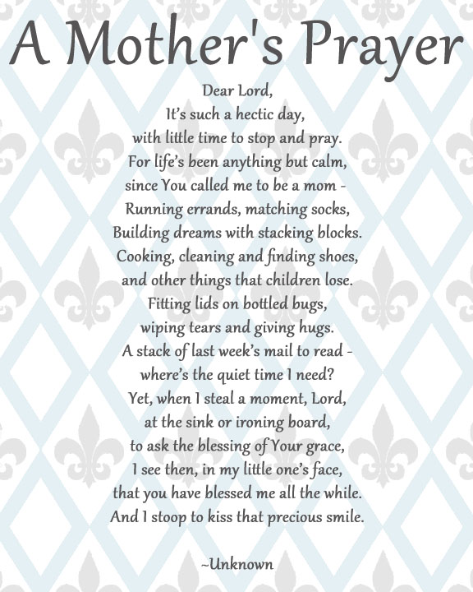

**Pastors Tom & Cristy Canterbury**

***PO Box 545***

***Lenore, WV 25676***

***304-475-3805***

**May 9, 2021**

**#imnotfamousbutimfruitful**

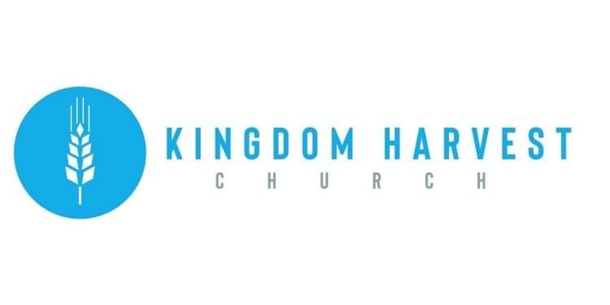

[***https://www.khchurch.com***](https://www.khchurch.com)

***Growing Families.***

***Harvesting the Kingdom.***





God blessed mothers with an unconditional love, wisdom, a caring temperament, a fun-loving attitude, heart, strength, insightfulness, fearlessness, a fighter spirit, tears, laughter, pride, joy, pain, faith, mercy, grace, peace…and so much more! It does not matter if a woman has given birth to a child, she is still a “mother” to those she cares for. Hug your mom if you still have her, pray for those that lost their mothers way too soon, and praise God for a mother’s strength to do all they do and still smile, laugh, and love…

We thank God for EACH OF YOU!



***Guest Speaker today is…***

Dr. Eric S. King is an ordained minister at Lakeside Christian Church in Lakeside, California, where he serves the body as a small group Bible teacher and Pastoral Staff Advisor. He holds a Bachelor and Master of Theology, as well as a Doctor of Ministry Degree from Destiny Christian University and a Bachelor of Science in Public Administration from Central Michigan University. Eric has served as the Founder and Lead Pastor of Spirit Life Temple in Clarkston, Michigan, until 2010, and is currently a US Representative for Judea Harvest Ministries in Johannesburg, South Africa. Dr. King connects with local Pastors to bring awareness and prayer support for Judea’s church planting, building, pastoral training, Bible College, and food growth programs.

**Church Announcements**

**May 9th** – Mother’s Day – Speaker – Eric King

**May 16th** – Evangelist Dennis Heber

**May 22nd** – Church Spring Cleaning – 10:00 to 1:00

**May 23rd** – Blessing of the Bikes Service-Speaker David Rice

**Cookout to follow – Dress in Biker Apparel**

***In the know…***

Any church info to be shared-please see Angie McComis and you’ll see it here!!

There are many ways to give at Kingdom Harvest…

1. <https://www.khchurch.com>; click on the “Giving” tab
2. Text **kingdomharvestwv** to77977 & follow instructions
3. Black basket at the front door

**SERVICE TIMES**

Sunday Teen Group Meeting

9:30 AM

Sunday Morning Service & POWER KIDS

11:00 AM

Wednesday Prayer Service

7:00 PM

Grass-Cutting Schedule

**REMINDER: If you would like to help with lawn care at KHC contact Leonard Lucas or Harold Preece.**

**Teens Night Out!!**

Bowling…Saturday, May 22

The Teens of KHC are “Striking” out for Fun!!

Come join us...more details to follow

**Lost & Found!**

**We have found a few items at the church that have lost their owners! If you have lost something from a previous visit, see Angie McComis**