

**MAY**

**Birthdays**

Lilah-Belle Damron 05/07

Hunter Shrum 05/18

**Spiritual Birthdays**

Neil & Stacy Ball *May 2010*

**Anniversary**

Dan & Kyla Smith 05/29



Blessings of the Bikes

May 23, 2021









May is a busy month…But God is never too busy to listen & care for you!

***But thou, O Lord, are a shield for me; my glory, and the lifter up of mine head. Psalm 3:3***

If you don’t know Jesus as your personal Savior, we encourage you to seek him and talk to Him, surrender all your cares upon Him, for He cares for you.

***For with the heart man believeth unto righteousness; and with the mouth confession is made unto salvation, Romans 10:10***

**Pastors Tom & Cristy Canterbury**

***PO Box 545***

***Lenore, WV 25676***

***304-475-3805***

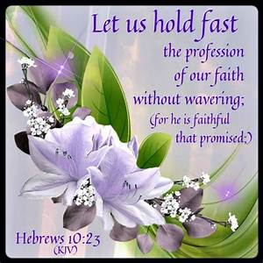

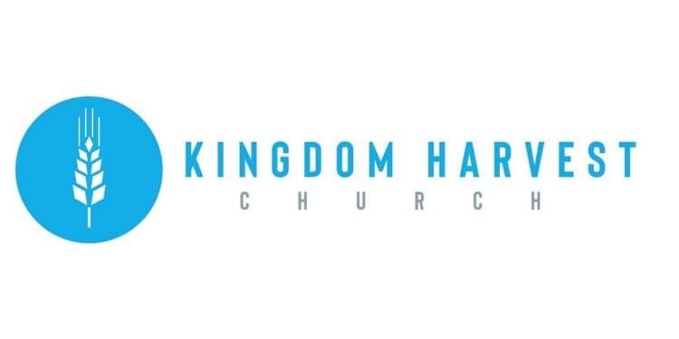

[***https://www.khchurch.com***](https://www.khchurch.com)

***Growing Families.***

***Harvesting the Kingdom.***

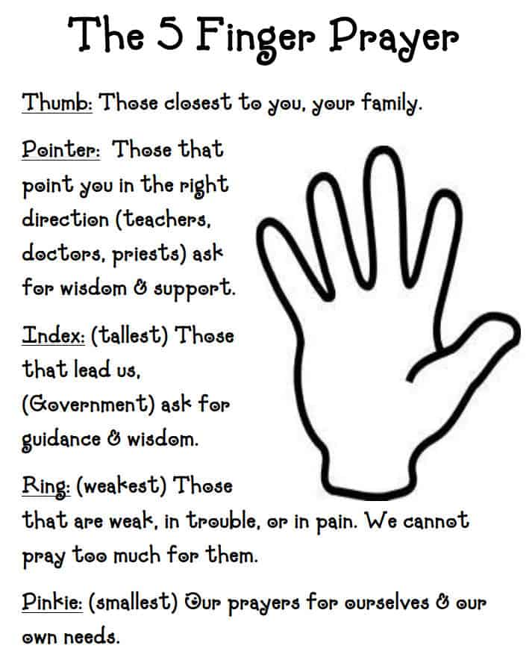****

**Church Announcements**

**May 9th** – Mother’s Day – Speaker – Eric King

**May 16th** – Evangelist Dennis Heber

**May 22nd** – Church Spring Cleaning – 10:00 to 1:00

**May 23rd** – Blessing of the Bikes Service-Speaker David Rice

**Cookout to follow – Dress in Biker Apparel**

***In the know…***

Any church info to be shared-please see Angie McComis and you’ll see it here!!

**2020 & 2021 Graduates!!**

KHC is so proud of YOU!

We would love to display all of our graduate’s pictures and info for the whole church to see…

Please bring a picture, where you are graduating from (school, degree, & honors) and give it to Cristy Canterbury.

F *orsaking*

A *ll*

I

T *ake*

H *im*

Blessings of the Bikes 2021

Sunday May 23, 2021

Join Kingdom Harvest Church for this one of a kind event!!

A prayer for safety, protection, and peace will be given over this year’s “Riding Season” for all bikers and Dave Rice will be bringing the Word. Then after a 2-hour bike ride (route will be announced the day of the ride), a cookout will be waiting for you when the bikers return!! Tell all your “Biker” friends (even those that don’t ride) to come and join us for fellowship, God’s glorious Word, and of course, great food!

We love you and want you to know that when you are at KHC, You Are FAMILY!!

Also, this event is on Facebook, listed as Blessing of the Bikes 2021…share and ask your friends to share…Come one, Come All

There are many ways to give at Kingdom Harvest…

1. <https://www.khchurch.com>; click on the “Giving” tab
2. Text **kingdomharvestwv** to77977 & follow instructions
3. Black basket at the front door

**SERVICE TIMES**

Sunday Teen Group Meeting

9:30 AM

Sunday Morning Service & POWER KIDS

11:00 AM

Wednesday Prayer Service

7:00 PM

Grass-Cutting Schedule

**REMINDER: If you would like to help with lawn care at KHC contact Leonard Lucas or Harold Preece.**

**Teens Night Out!!**

Bowling…Saturday, May 22

The Teens of KHC are “Striking” out for Fun!!

Come join us...more details to follow

**Lost & Found!**

**We have found a few items at the church that have lost their owners! If you have lost something from a previous visit, see Angie McComis**