

CHURCH ANNOUNCEMENTS

***Upcoming Events:* Mark your calendars!!**

**April 25th** – Evangelist Dennis Heber

**May 23rd** – Blessing of the Bikes Service-Cookout to follow



***In the know…***

Any church info to be shared-please see Angie McComis and you’ll see it here!!

**APRIL**

**Birthdays**

Phillip Lucas 04/09

Neil Ball 04/22

Donetta Shrum 04/26

**Spiritual Birthdays**

Lilah-Belle Damron 04/04

Sadie Damron 04/07

Paige Akers 2007

Chris Akers 04/09

**Anniversary**

Bob & Judy Adkins 04/15

Justin & Brionna Shrum 04/13





**SERVICE TIMES**

Sunday Teen Group Meeting

9:30 AM

Sunday Morning Service & POWER KIDS

11:00 AM

Wednesday Prayer Service

7:00 PM





There are many ways to give at Kingdom Harvest…

1. <https://www.khchurch.com>; click on the “Giving” tab
2. Text **kingdomharvestwv** to77977 & follow instructions
3. Black basket at the front door

It’s Grass-Cutting Season

**Anyone interested in helping with the lawn care at KHC should contact Leonard Lucas or Harold Preece. They will make a schedule to keep God’s house looking clean & green!**

**Sign Up Today!!**



**\*\*Sanctuary Carpet\*\***

**KHC will be getting quotes for**

**new carpet in the sanctuary.**

**We all know that God’s house is to look its best!!**

**More details as they become available...**

**Pastors Tom & Cristy Canterbury**

***PO Box 545***

***Lenore, WV 25676***

***304-475-3805***





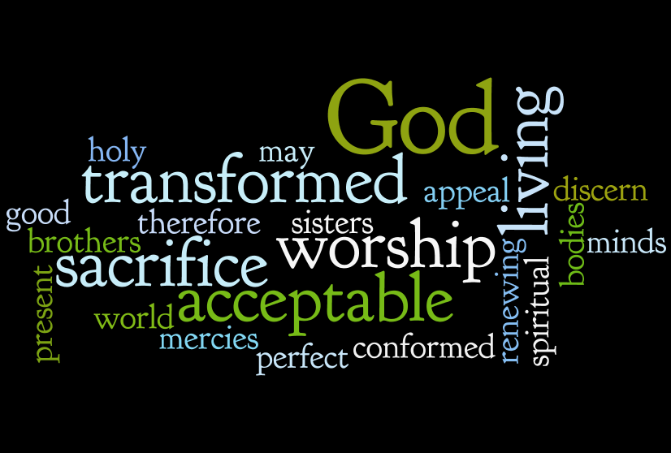

**And they that be wise shall shine as the brightness of the firmament; and they that turn many to righteousness as the stars for ever and ever.**

**Daniel 12:3**

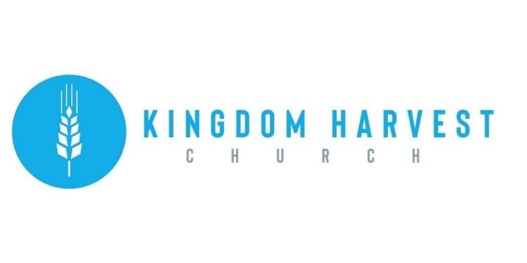



[***https://www.khchurch.com***](https://www.khchurch.com)

***Growing Families.***

***Harvesting the Kingdom.***

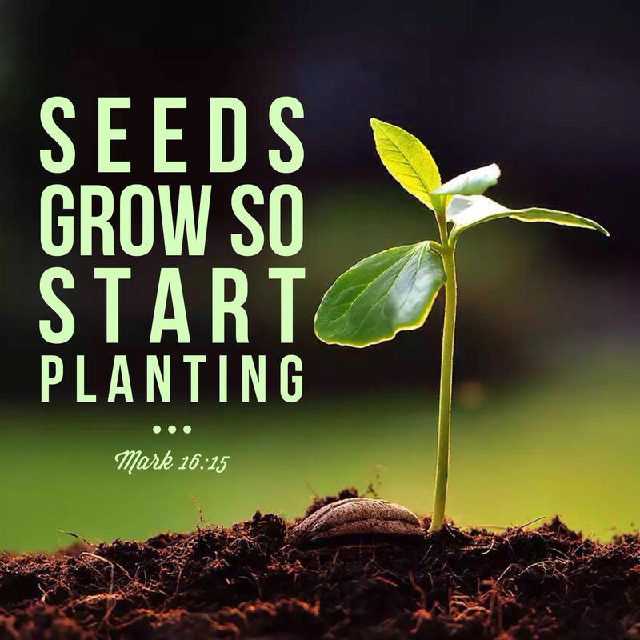********

**Lost & Found!**

**We have found a few items at the church that have lost their owners! If you have lost something from a previous visit, see Angie McComis**

**Planting Seeds**

*By Greg Laurie on Jan 16, 2013*

*I planted the seed in your hearts, and Apollos watered it, but it was God who made it grow. It's not important who does the planting, or who does the watering. What's important is that God makes the seed grow.*

We don’t read of anyone in Scripture actually sharing the gospel with Saul (who later became the apostle Paul). But God used a number of people to prepare his heart to receive it.

As far back as I can remember in my life, no one ever sat me down and said, "Greg, here is how you can come into a relationship with Jesus Christ."

I would hang out at the Balboa Fun Zone in Newport Beach and lean up against walls, trying to look tough and cool. I would watch Christians hand out religious materials and engage people in conversation, and I would be saying in my heart, *Please talk to me*. But they would never talk to me—they just offered me their tracts.

I shoved those tracts into my pocket and never threw one of them away. I had a drawer at home designated for religious material, and I deposited everything that was handed to me into that drawer. Every now and then, I pulled out the drawer, dumped it on my bed, and read through the material, trying to make sense of it all. What I needed was someone to show me the way.

Then one day, I eavesdropped on a Bible study that was being held on the lawn of my high school campus. And that is when I first heard the gospel and became a Christian.

Looking back, there were different people who helped get me ready for that moment. My grandparents were Christians and took me to church. I had the influence of an aunt and uncle who were strong Christians. Even watching Billy Graham on television with my grandparents was one of the many seeds that were sown in my life.

You see, we all have a part to play in God’s kingdom. We all can do something.

<https://harvest.org/resources/devotion/planting-seeds/>

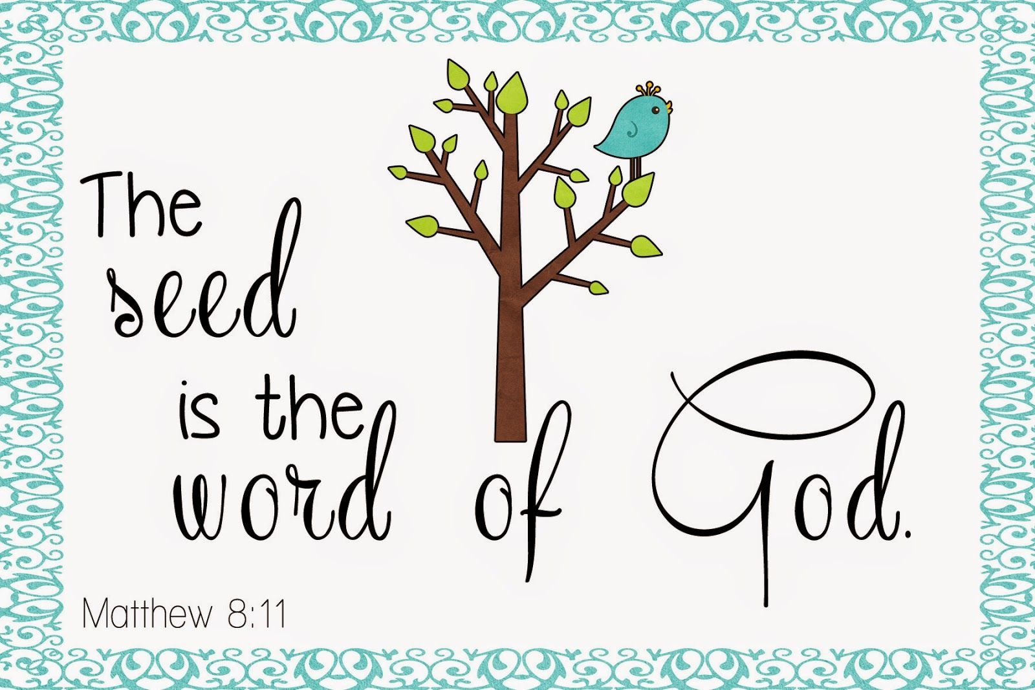

**Teens Night Out!!**

Bowling…Saturday, May 22

The Teens of KHC are “Striking” out for Fun!!

Come join us...more details to follow

**2020 & 2021 Graduates!!**

KHC is so proud of YOU!

We would love to display all of our graduate’s pictures and info for the whole church to see…

Please bring a picture, where you are graduating from (school, degree, & honors) and give it to Cristy Canterbury.

**Welcome to**

**KINGDOM HARVEST CHURCH**

**April 25, 2021**

***John 3:16***

***For God so loved the world, that He gave His only begotten Son, that whosoever believeth in Him should not perish, but have everlasting life.***