****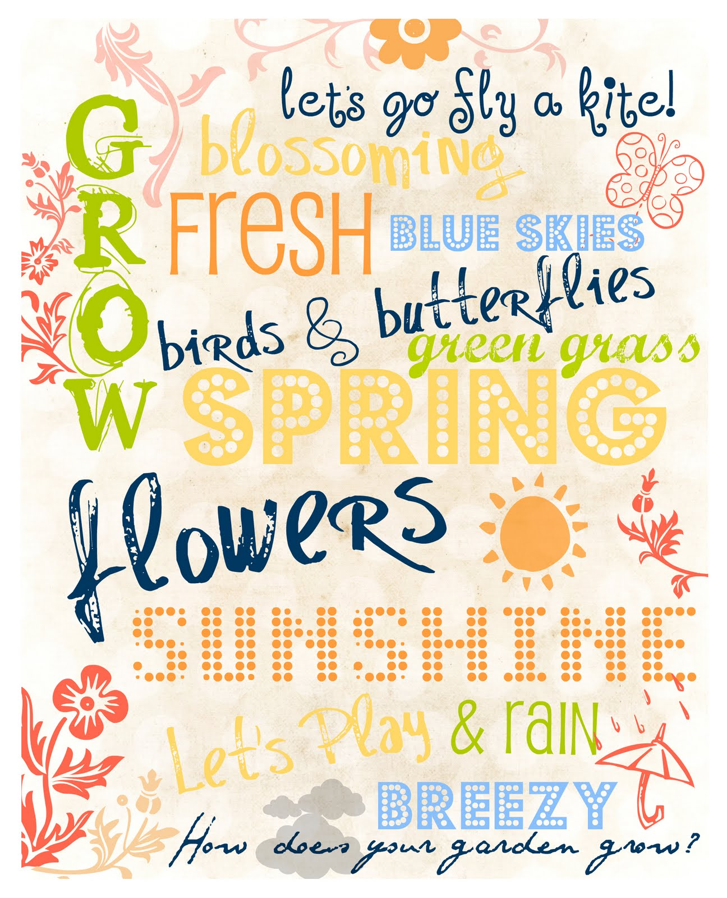**

CHURCH ANNOUNCEMENTS

***Upcoming Events:* Mark your calendars!!**

**April 25th** – Evangelist Dennis Heber

**May 23rd** – Blessing of the Bikes Service-Cookout to follow



***In the know…***

Any church info to be shared-please see Angie McComis and you’ll see it here!!

**APRIL**

**Birthdays**

Phillip Lucas 04/09

Neil Ball 04/22

Donetta Shrum 04/26

**Spiritual Birthdays**

Lilah-Belle Damron 04/04

Sadie Damron 04/07

Paige Akers 2007

Chris Akers 04/09

**Anniversary**

Bob & Judy Adkins 04/15

Justin & Brionna Shrum 04/13





**SERVICE TIMES**

Sunday Teen Group Meeting

9:30 AM

Sunday Morning Service & POWER KIDS

11:00 AM

Wednesday Prayer Service

7:00 PM





There are many ways to give at Kingdom Harvest…

1. <https://www.khchurch.com>; click on the “Giving” tab
2. Text **kingdomharvestwv** to77977 & follow instructions
3. Black basket at the front door

It’s Grass-Cutting Season

**Anyone interested in helping with the lawn care at KHC should contact Leonard Lucas or Harold Preece. They will make a schedule to keep God’s house looking clean & green!**

**Sign Up Today!!**



**\*\*Sanctuary Carpet\*\***

**KHC will be getting quotes for**

**new carpet in the sanctuary.**

**We all know that God’s house is to look its best!!**

**More details as they become available...**

**Pastors Tom & Cristy Canterbury**

***PO Box 545***

***Lenore, WV 25676***

***304-475-3805***





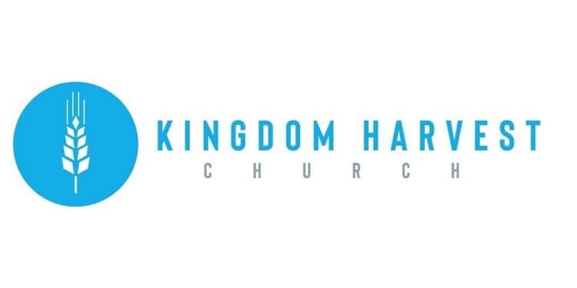



[***https://www.khchurch.com***](https://www.khchurch.com)

***Growing Families.***

***Harvesting the Kingdom.***



**Welcome to**

**KINGDOM HARVEST CHURCH**

**April 18 2021**

***Isaiah 61:11***

***For as the earth brings forth its sprouts,***

***And as a garden causes the things sown in it to spring up,***

***So the Lord God will cause righteousness and praise to spring up before all the nations.***

**Don’t You Just Love Spring?**

It’s so refreshing after the cold winter to feel some warmth from the sun and to see plants coming to life again.  I love it.  Don’t you?

Do you notice how quickly a small flower bud opens up into a magnificent blossom?  Every spring I am amazed to see how quickly the little buds pop out of branches, bushes, and the ground.  And then I get excited as within days the buds burst open into leaves, blossoms, and flowers.  Just a little nutrition from the soil, warmth from the sun, and spring rain cause the unfolding of glorious beauty all around us.

**Are You God’s Flower Garden?**

If you love and follow Jesus, YOU are God’s flower garden.  The living Word of God, spoken into your life, contains everything needed to unfold the glory of God in your life.  Maybe you feel like you’ve been plowed under by the weight of problems and struggles for too long.  Watch and see how that plowing is preparing you to become a beautiful garden.

**Where Did Your Seeds Come From?**

God sees what you can’t see. He has been planting many seeds into your life, and you don’t always realize that they are there. These seeds may have come from others sharing spiritual truth with you. Or perhaps reading the Bible and certain circumstances have drawn your attention to God.  Other ways these seeds have been planted are through words of encouragement, Christian music, and sermons, as well as through the Holy Spirit teaching you.

**How To Blossom**

All you need is to add spiritual nutrition through prayer and meditating on His Word.  Soak up the warm Sonshine of Jesus’ love.  And open your heart to let the water of the Holy Spirit flow into you and then out through you.  As you do, the seeds will grow and poke up through the good soil of your spirit.  (If your spirit hasn’t been good soil, ask His forgiveness and ask Him to make you into good soil.) Suddenly buds will pop out and bloom.  You’ll find yourself singing His praises.  As you worship in spirit and in truth, the glory of His Presence will manifest in your life.  You will be His beautiful flower garden.  The loveliness and fragrance will draw others to Jesus.

<https://www.daily-devotionals.com/you-are-gods-flower-garden/>

**We Are Family!!**

**Our church is growing!!**

Though we all may not know each other (yet) we are excited to see each of you every week… or today for the 1st time!

We appreciate it that your chose to spend your Sunday morning with us!

We also have a midweek service on Wednesdays @ 7:00pm

**Come Join US**



**Happy Birthday – Anniversary – Spiritual Birthday**

Give us your dates and we’ll all share in celebrating with you!!

God has blessed us with life…physically & spiritually!!

Let Angie McComis know your dates by completing the registry insert…and let the partying begin☺!

