

Sunday Teen Group Meeting

9:30 AM

Sunday Morning Service & POWER KIDS

11:00 AM

Wednesday Prayer Service

7:00 PM

There are many ways to give at Kingdom Harvest…

1. <https://www.khchurch.com>; click on the “Giving” tab
2. Text **kingdomharvestwv** to77977 & follow instructions
3. Black basket at the front door





It’s Grass-Cutting Season

**Anyone interested in helping with the lawn care at KHC should contact Leonard Lucas or Harold Preece. They will make a schedule to keep God’s house looking clean & green!**

**Sign Up Today!!**



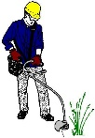

**\*\*Sanctuary Carpet\*\***

**KHC will be getting quotes for**

**new carpet in the sanctuary.**

**We all know that God’s house is to look its best!!**

**More details as they become available...**



**Pastors Tom & Cristy Canterbury**

***PO Box 545***

***Lenore, WV 25676***

***304-475-3805***





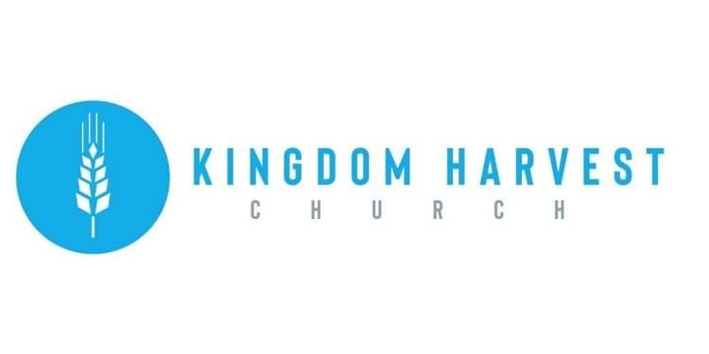

[***https://www.khchurch.com***](https://www.khchurch.com)

***Growing Families.***

***Harvesting the Kingdom.***

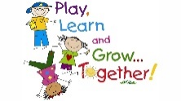

April is **Autism** Awareness Month.

What does God’s word say about autism?

**Psalm 139:14** *I will praise thee; for I am fearfully and wonderfully made: marvelous are thy works; and that my soul knoweth right well.*

**Proverbs 22:6** *Train up a child in the way he should go: and when he is old, he will not depart from it.*

**Psalm 103:17** *But the mercy of the Lord is from everlasting to everlasting upon them that fear him, and his righteousness unto children’s children*

**Welcome to**

**KINGDOM HARVEST CHURCH**

**April 11 2021**

***Prayer for Autism and Special Needs***

Father God, we just thank you for children who are facing autism and experiencing sensory overload. We also pray for those who have special needs, children and adults, who may have other things going on in their bodies and mind that they’re not able to control. They are in your hands and you see them, Oh God.

We come against the enemy and any spirit that will want to overwhelm them, in the name of Jesus. We pray for freedom in their spirits to be who you called them to be. We pray for healing in their bodies, mind, soul and spirit. Where there’s any deficiencies that you make up the deficiency Father God that you fill them up Lord God with your healing virtue. We thank you that by Jesus’ stripes they are healed.

We call out any spirit of infirmity or sickness or weakness in their bodies and even this spirit of delay, in the name of Jesus. We sent it back to dry places from whence it came. Even the challenges that they are having in this world, Lord, we pray You make every crooked road straight, in the name of Jesus. We declare healing over our children with challenges. We pray Lord God that the body of Christ would accept and embrace our children the way You accept and embrace our children. Our love is truly on trial – can we love those who maybe don’t fit the framework of what we think people should be? Help us Lord God to see people as people and to love them with the heart and the compassion that Jesus Christ has for us.

Father, we thank you that even that our children and adults with special needs are still be useful in the kingdom. We thank you Father God that for your word that says train up a child in the way they should go and when they are old they will not depart from it. We pray that their giftings would come forth, in the name of Jesus.

We pray that the body of Christ would recognize that where there is a deficiency You make up the gap in other areas. Thank you for their superior intelligence and the true gift that they are from you – a gift to this world. Thank you, Oh God, for their enhanced ability to love us even when Your people don’t show the love of Christ towards them and acceptance towards them. Cover them Lord and shelter them from rejection and fear.

Lord God, in the name of Jesus, encourage and strengthened the hearts and minds of the parents and care givers that are raising children that are having challenges, whatever they may be. Father we pray that you give them wisdom on how to raise these children that are truly a gift from God. Give them the wherewithal and whatever is needed to raise your children to bring out the best in these children so that they will be able to fulfill your purpose for their life.

We ask, Lord God, that Your body will see these children with eyes of love, eyes of caring, eyes of patience and develop us in the fruit of the Spirit. Help us to examine our own fruit and prune us so that we will bear much more fruit.

Father we abide, remain, habitate in your vine, in the name of Jesus Christ we pray.

**We Are Family!!**

**Our church is growing!!**

Though we all may not know each other (yet) we are excited to see each of you every week…or today for the 1st time!

We appreciate it that your chose to spend your Sunday morning with us!

We also have a midweek service on Wednesdays @ 7:00pm

**Come Join US**



**Happy Birthday – Anniversary – Spiritual Birthday**

Give us your dates and we’ll all share in celebrating with you!!

God has blessed us with life…physically & spiritually!!

Let Angie McComis know your dates by completing the registry insert…and let the partying begin☺!

