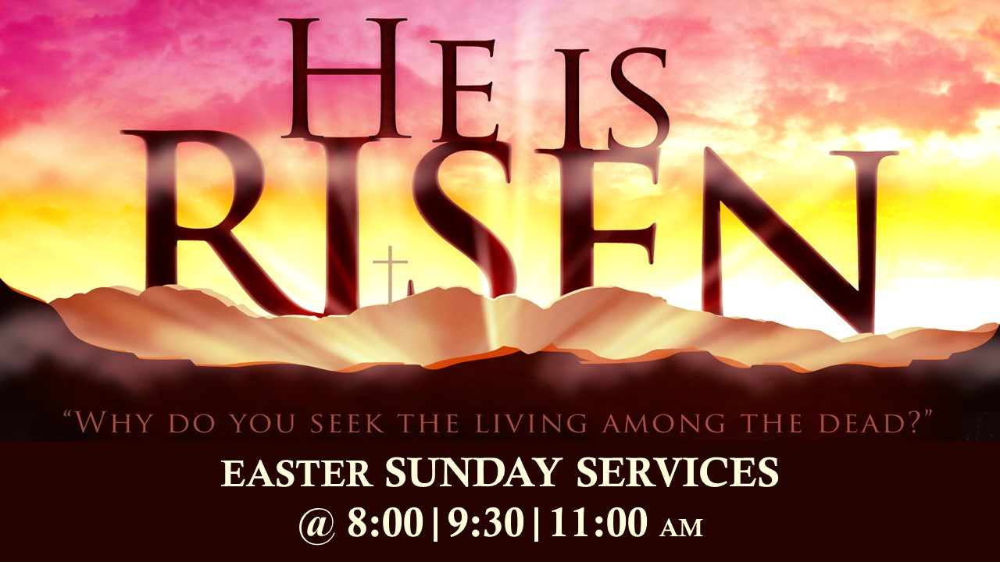

Teen Group Meeting

9:30 AM

Sunday Service & POWER KIDS

11:00 AM

Wednesday Prayer Service

7:00 PM

Sunday Service & POWER KIDS

11:00 AM

Wednesday Prayer Service

7:00 PM



**Philippians 4:4**

**Rejoice in the Lord always: and again I say, Rejoice!!**

**11:00 AM**

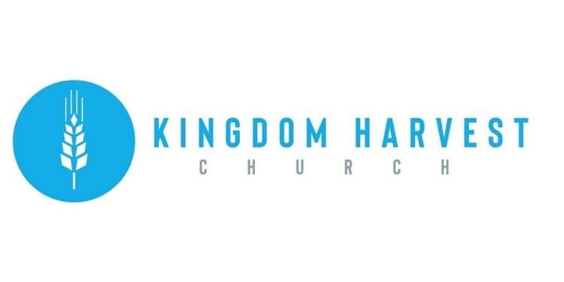

**Pastors Tom & Cristy Canterbury**

**Lenore, WV**

**304-475-3805**

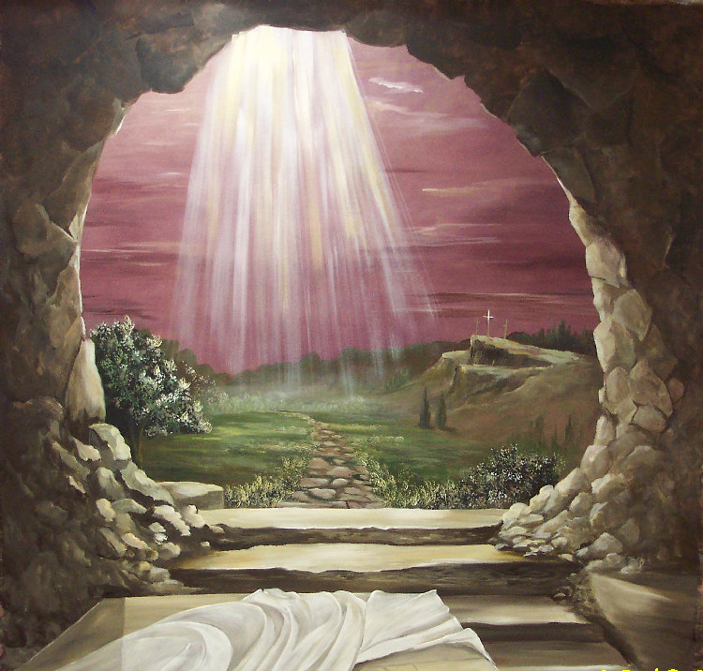

**Welcome to**

**KINGDOM HARVEST CHURCH**

**Easter Sunday**

**April 4, 2021**

**We Are Family!!**

**Our church is growing!!** Though we all may not know each other (yet) we are excited to see each of you every week…or today for the 1st time!

We appreciate it that your chose to spend your Sunday morning with us!

We also have a midweek service on Wednesdays @ 7:00pm

**Come Join US**

**EASTER SUNDAY**

The story of Easter is the story of an empty tomb. No one knows with complete certainty where the tomb of Jesus was located, but this shouldn’t be surprising. After the resurrection, the location of the tomb didn’t matter anymore since Jesus was no longer in it!

Praise God!! Because He lives…I can face tomorrow!!

Jesus….Jesus…Jesus! How we love His name!!!



**Happy Birthday – Anniversary – Spiritual Birthday**

Give us your dates and we’ll all share in celebrating with you!!

God has blessed us with life…physically & spiritually!!

Let Angie McComis know your dates by completing the registry insert…and let the partying begin☺!

