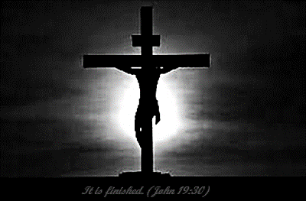

Teen Group Meeting

9:30 AM

Sunday Service & POWER KIDS

11:00 AM

Wednesday Prayer Service

7:00 PM

**It’s Friday…**

**but, Sunday’s coming!!**

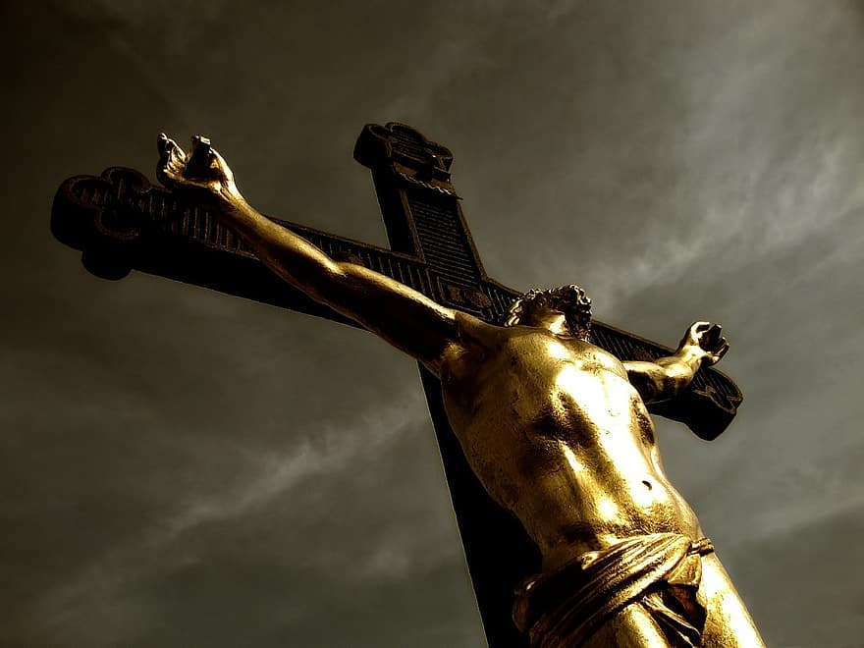

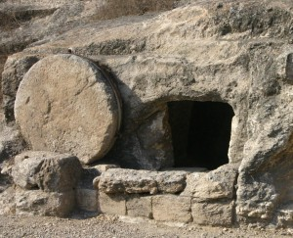



**Pastors Tom & Cristy Canterbury**

**Lenore, WV**

**304-475-3805**



**Intercede for Sunday’s Service…**

**Easter Sunday**…some may attend because of an invite from a family member or friend. Let’s all pray (intercede) on their behalf, that, when they hear the Gospel (Good News), their hearts will long to know Jesus more…that they will take that first step…that they will receive the Good News…and become a Child of God!!

**Good Friday**

Good Friday is observed on the Friday before Easter Sunday. On this day Christians commemorate the passion, or suffering, and death on the cross of Jesus Christ. The biblical account of Jesus’ death on the cross, His burial, and His resurrection can be found in the following passages: Matthew 27:27-28:8; Mark 15:16-16:19; Luke 23:26-24:35; and John 19:16-20:30.

**Welcome to**

**KINGDOM HARVEST CHURCH**

**April 2, 2021**

When Jesus therefore had received the vinegar, he said, **IT IS FINISHED**: and he bowed his head, and gave up the ghost. John 19:30

**We Are Family!!**

**We are excited to see each of you as this evening!**

**Though we all may not worship in the same church each week, we all serve the same wonderful Jesus! And Good Friday is just the beginning of a weekend that changed every evil plan of the enemy!! Praise God for His wondrous plan!!**

**Sing! Shout! Raise your hands to Jesus!**

**Thank You for Joining US**

**Our special speaker tonight will be …**

**Pastor Terry Blankenship**

Pastor Terry is an ordained minister in the Assemblies of God; he served 15 years in the Assembly of God at Matewan, WV, as a Board Member, Sunday School Superintendent, Teacher, Preacher, and Bus Driver. He was also one of the founders of Omega Christian Academy, located in Matewan, WV. Pastor Terry has been the pastor at Victory Christian Center since February 1994. Terry gives God all the glory for all the blessings in his life. Pastor Terry will celebrate 44 years of marriage with his beautiful wife, Brenda, this September.