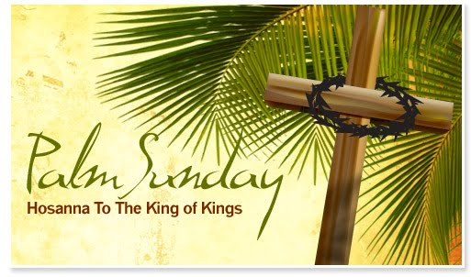

Sunday Service & POWER KIDS

11:00 AM

Wednesday Prayer Service

7:00 PM



Senior Pastor’s Vision

Pastor Tom’s message of faith and the establishing of God’s kingdom is always timely. His burning vision is to not just have a church that exists within the community, but to have a community thriving within the congregant’s everyday lives, allowing Matthew 6:10 (“Thy kingdom come, Thy will be done in earth, as it is in heaven.”) to come to pass. His passion is to see Kingdom Harvest Church move beyond the bounds of national ministry and step into the realm of international impact.

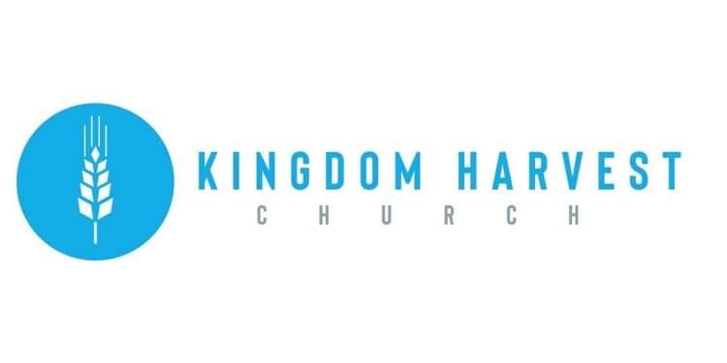

**Pastors Tom & Cristy Canterbury**

**Lenore, WV**

**304-475-3805**





**Happy Birthday – Anniversary – Spiritual Birthday**

Give us your dates and we’ll all share in celebrating with you!!

God has blessed us with life…physically & spiritually!!

Let Angie McComis know your dates by completing the registry insert…and let the partying begin☺!



**We Are Family!!**

**Our church is growing!!** Though we all may not know each other (yet) we are excited to see each of you every week…or today for the 1st time!

We appreciate it that your chose to spend your Sunday morning with us!

We also have a midweek service on Wednesdays @ 7:00pm

**Come Join US**

**Our special speaker today will be …**

**Evangelist Dennis Heber**

Dennis Heber is a world Evangelist & President of Bible Revivals, a non-profit evangelistic ministry, and an instructor at Grace Bible Institute & Destiny Bible College. His ministry has taken him from the inner-city streets, tents, & churches of Cleveland, OH, to the shores and doors of places and people around the world preaching in over 50 countries. His humor & spiritual insight are combined to make an experience that will be challenging and life changing. Rev. Heber was ordained in 1978. He and his wife, Julie, have one daughter and three grandsons; they reside in Rocky River, OH

**Welcome to**

**KINGDOM HARVEST CHURCH**

**MARCH 28, 2021**

**PALM SUNDAY**

The Palm Sunday story comes to life in the Bible in Matthew 21:1-11; Mark 11:1-11; Luke 19:28-44; and John 12:12-19. The Triumphal Entry of Jesus Christ into Jerusalem marks the high point of his earthly ministry. The Lord enters the city, knowing full well that this trip will end in his sacrificial death for the sin of humanity…Join us today as we celebrate Palm Sunday with the assurance that Christ’s sacrifice gave us a way back to the Father!